Monticello Lodge No. 532
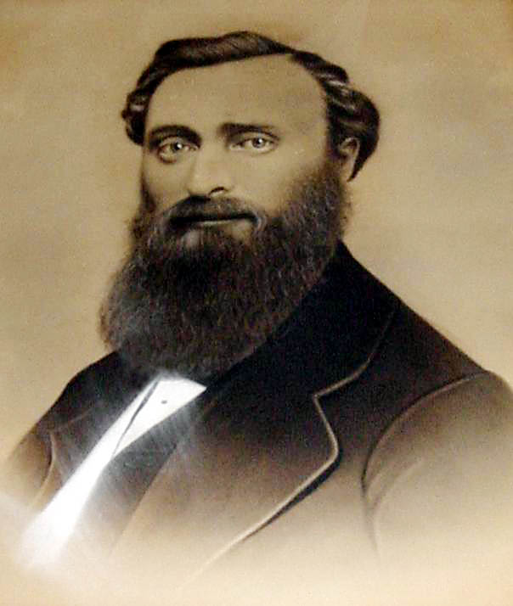

DAVID G. STARR
The first master of Monticello Lodge served through the trying years of the Civil War, became District Deputy Grand Master for the Seventh District during the years 1866 and 1867 and again was Master of Monticello Lodge during the years 1868 and 1869.

It is unlikely that any fraternal organization in Monticello has enjoyed a more respected and noteworthy existence than that which Monticello Lodge No. 532 has experienced since the Civil War days when it was, formed.
The lodge received dispensation empowering it to work during the most critical times Americans had endured since the days of Valley Forge. In the formative days of the lodge the nation was engaged in the second year of a civil war and the more serious problems of the day were requiring the attention of the average citizen. The birth of Monticello Lodge was contemporaneous with the forfeiture of the charter of Lodge No. 460, which had been organized three years before only to fail because of conditions I brought on by the war. The organizers fully realized how seemingly impossible it would be to attempt organization of another lodge but nevertheless refused to resign themselves to believing that it would be impossible to successfully organize and continue a new lodge.
The failure of Monticello Lodge No. 460 was a severe blow to those who had diligently practiced Masonry. An attempt to revive the old lodge was unsuccessful 80 the next best move was to ask another lodge to recommend the formation of a new lodge, in Monticello. The only other active lodge in the county at that time was Callicoon Lodge No. 521, which was located at Thumansville.
A recommendation outlining the request of the Monticello brethren was favorably received by Grand Master John J. Crane and on December 27, 1862, dispensation was granted. Serving then as Grand Secretary was James M. Austin.
The first meeting under dispensation was conducted on January 10, 1863, with David G. Starr, Master; James Matthews, Senior Warden; Elias Pelton, Junior Warden; John A. Thompson, Senior Deacon; Solomon Royce, Junior Deacon; Bradley Hall, Secretary, and Lewis Dickinson, Tiler. Hall, Thompson and Matthews were appointed by the Master to draft by-laws.
Business included the passing of a resolution “to meet every Wednesday at 7:30 p. m. till further ordered.”

Charter Members Lodge 532

Listed as charter members were:
David G. Starr, lawyer, Monticello; James Matthews, lawyer, Monticello; Eli S. Pelton, farmer, Monticello; Solomon W. Royce, hotelkeeper, Monticello; John A. Thompson, lawyer, Monticello; Lewis Dickinson, carpenter, Monticello; F.M. St. John, gentleman, Monticello; Stephen W. Royce, merchant, Monticello; A.J. Bush, lawyer, Parksvllle; A.J. Wood, hotel, Woodbourne; Charles R. Kelton, painter, Monticello; Stephen Sweet, hotel, Bethel; David J. Knapp, mechanic, Fallsburgh; Isaac C. Knapp, farmer, Fallsburgh; Melvin S. Wells, lawyer, Liberty; William Roper, farmer, Cochecton; Jesse L. Towner, merchant, Monticello; Reuben K. Scudder, teacher, Monticello; O.E. Crandall, merchant, Monticello; P. F. Perry, inn-keeper, Mongaup Valley; Charles Meyers, dealer, Monticello; John M. Seeley, farmer, Fallsburgh; James E. Quinlan, printer, Monticello; John B. Nixon, teacher, Monticello; F.W. Johnston, merchant, Barryville; A. B. LeRoy, farmer, Parksville; William A. Rice, farmer, Glen Wild; James C. Curtis, assessor, Cochecton; John Miliken, blacksmith, Woodbourne; N.L. Stern, dealer, Monticello; F. Wheeler, farmer, Thompson; N. W. Rumsey, farmer, Monticello; C. S. Starr, farmer, Monticello; Edwin Bowen, merchant, Monticello; O.A. Carroll, surgeon, U.S. Army; George W. Jones, blacksmith, Woodbourne; G.O. Canfield, physician, Barryville; Jacob Depuy, farmer, Woodbourne, and Martin F. Merritt, farmer, Woodbourne.
All of the charter members, except six, were Master Masons. Of the latter four were still Entered Apprentices. Charter members were those who had associated with the new lodge before June 11, 1863.
Bro. Starr was a lawyer of exceptional ability and attainments. He served from the lodge's beginning through 1865, served as District Deputy Grand Master of the 7th Masonic District through 1866 and served again as Master in 1868 and 1869.
He was raised in Monticello Lodge No. 460 on April 1, 1861, with Bradley Hail, the latter having served as the first secretary of Monticello Lodge No. 532. Others raised the same evening were William Hill and Fred Field.
Brother Starr was Senior Warden of Monticello Lodge No. 460 when its last meeting was conducted on September 14, 1861, and E.C. Howard was in the East. Howard had bean called to arms and the duties of Master were then assumed by Starr, who served in the Oriental Chair until inactivity and failure to make returns to Grand Lodge resulted in forfeiture of the charter.
Again he found himself Master in 1862. He now headed a new lodge. Conditions then, as we find them today with a country at war, caused a loss in attendance of both officers and members who were called to give their attention to the urgent problems of the day.
As the turning point of the war came in the early days of July 1863, with the victories of Vicksburg and Gettysburg, several stars already had been sewed in the lodge's flag, but by 1865, just before the surrender of General Robert E. Lee to General U. S. Grant at Appomattox, Va., on April 9th, when the Union had more than a million In its army there were few officers or members to continue lodge work. Many of the sideliners who were not in the service found it impossible to keep up their financial responsibilities respecting the lodge.
Brother Starr worked hard and long to continue under the original charter No. 460 but despite his organizing ability and wise counsel he failed.
After the war Bro. Howard settled in Alleganey, N. Y., and affiliated with Olean Lodge No. 252 there.
The letter he wrote requesting information "in regard to his record" mentions the fact that he was Master of Lodge No. 460. The letter, therefore, is interesting.
The letter is directed to J.M. Austin, Grand Secretary, and reads as follows:

Allegany, March 23, 1867.
J. M. Austin, Grand Secretary.
Dear Sir-
In the year 1862 I was W. M. of Monticello Lodge 460 and entering the U. S. service left the charter with the Senior Warden. I wish now to affiliate with Olean Lodge 252. They wish information in regard to my record. Please give me this information over your signature and oblige,
Respt. yours,
E. C. HOWARD,
Allegany, N. Y.

The first men to be initiated, passed and raised in Monticello Lodge No. 532 were F.M. St. John and Stephen Royce. Both signed the by-laws and book of constitution on February 25, 1863. The first affiliates were A.J. Bush, who later distinguished himself as County Judge; A.J. Wood, Charles R. Kelton, who was to serve as Master in 1871, and Stephen Sweet. All four affiliated on February 5, 1863.
At the January 21, 1863, meeting a committee consisting of Brothers Hass, Thompson and Matthews recommended that Lodge No. 532 adopt the same by-laws as Lodge No. 460 insofar as they could be made applicable to the new lodge.
Receipts for the evening amounted to $42. On February 25, 1863, Bro. James D. Decker of Port Jervis Lodge No. 328, A. Sander, Callicoon Lodge No. 521; Isaac Anderson, James C. Curtis and E. Burnham, "Ancient" Masons of Sullivan Lodge No: 272, "now extinct"; F. Wheeler, Chas. Meyers, F.W. Johnston and A.B. LeRoy were recorded as visitors.
It is interesting to, note that Bros. Anderson, Curtis and Burnham were listed as Ancient Masons.
This title is believed to have been bestowed upon the brethren because of their membership with Sullivan Lodge No. 272, which had received its dispensation in 1811 from an Ancient Grand Lodge.
There are no records available which would indicate that Brothers Curtis, Burnham and Anderson were then members of an active lodge but nevertheless it must be remembered that they must have satisfied Masons as to their eligibility to attend meetings.
Before a reconciliation of the Ancient and Modern lodges in 1813 Ancient lodges appear to have worked on an independent system claiming the original right which every body of Masons had to assemble and work without a warrant. Although it doesn't seem possible it nevertheless could have been this belief which prompted Brother Curtis and other members of Sullivan Lodge to refuse to surrender the charter of Sullivan Lodge No. 272 when declared forfeited in 1835 and they probably produced their charter to prove their membership.
At the completion of this third year as Master of Monticello Lodge No. 532 Bro. Starr proudly reported a membership of 77 Master Masons and six Entered Apprentices. Thirty-five were farmers, others were mechanics, lawyers, blacksmiths, hotelmen and workers who earned their livelihoods in tanneries, of which there were then 41 in the county.
Brother Starr found it difficult to foster the new lodge from infancy to a more mature condition and frequently found it difficult to find substitutes for the elected officers who had gone to war.
Despite these conditions, however, the lodge purchased its share of the 730 Government bonds and took care of its Masonic obligations.
At a meeting on July 2, 1864, it was resolved that the lodge recommend the establishment and organization of a lodge at Cochecton, "agreeably to a request of several Master Masons from that town". Bro. Alfred J. Baldwin, the Senior Warden, and as Master during this meeting. The result of the recommendation was the establishment of a new lodge which convened for the first time on Saturday evening, September 3, 1864, with Tobias R. VanGelder as Master.
Dedication of the new lodge, which took place on July 7, 1864, was attended by both brethren and officers of the mother lodge.
On November 16 of the same year, it was resolved that Monticello Lodge "recommend approval o~ an application from our brethren at Ellenville asking for dispensation to organize a lodge of F. & A. M. at that place." Many are of the opinion that the Ellenville lodge instituted in 1865 and now known as Wawarsing Lodge was mothered by Kingston Lodge No. 10, but there is no foundation for such a belief either in Grand Lodge records or in the old minute book of Monticello Lodge No. 532.
Although two lodges saw their beginning when Bro. D.G. Starr was Master in 1864 he was not present at either of the meetings when requests were presented. A.J. Baldwin acted as Master at the first meeting and Fred Field was acting as Master when the second petition was presented.
Although President Abraham Lincoln was assassinated during the last year of Brother Starr's three-year interim as Master and uncertainty existed through the country he enjoyed an eventful and most successful lodge year. A score of new members were added to the lodge roster and an unusually great number of meetings were both interesting and successful.
At the lodge's 123rd regular communication, held on December 21, 1866, Fred A. Field, a twenty-eight-year-old civil engineer, was elected to succeed Starr as Master.
Bro. Field had been elected to membership in Monticello Lodge No. 460 on November 28, 1860. He immediately became well versed with the ritual in that lodge and served as Senior Warden "pro tem" in place of J.W. Hammond, who joined the army at the opening of the Civil War.
Field affiliated with Monticello Lodge on April 30, 1864, and had been a member less than a year when elevated to the Oriental East.
Present during the installation ceremonies on January 10, 1866, was R.W. D.G. Starr, who had retired as Master to take over the duties of the first Deputy Grand Master for the 7th Masonic District. Also present was M.S. Wells, Acting Grand Marshall.
Field had spent his youth and early manhood at his father's hotel (the Rosalie Hotel site on East Broadway): Although he served only a year and a half as Master the record of his accomplishments indicate that he worked tirelessly and earnestly for the good of the lodge, securing its future and building a lodge reputation to be enjoyed throughout the years.
One of his first acts as Master was the planning of a Masonic festival which was held on February 15, 1866, for the purpose of creating a fund for the Masonic; Hall and Asylum."
Brother Field was a loyal Mason and was determined that he and the brethren adhere to the principles it propounded. When' a brother strayed he would first attempt to return him to the fold with kind advice but when this failed he would not hesitate to use sterner measures.
Under his leadership steps were taken which resulted in the expulsion of those who were found guilty of un-Masonic conduct. Two were the Gumaeur brothers, George and Hiram. Hiram submitted an answer to the charges at a regular communication on April 11th, 1866. He denied the second of two charges (neither of which were recorded) against himself and pleaded his brother George guilty of both charges. The lodge then considered the first charge against Hiram and voted to reprimand him. The lodge voted to expel George Gumaeur. R.W. D.G. Starr did the reprimanding.
On September 15, 1866, Hiram was formally charged with having become "beastly intoxicated on the 30th day of May, 1866, and conducting himself in a disorderly and un-Masonic manner to the great discredit of himself and disgrace of the honorable fraternity to which he belongs."
Hiram appeared to answer these charges on October 6, 1866, by asking for a demit, which was denied. He was expelled on March 3rd, 1867. Albert Wyckoff, the third Mason against whom similar charges were made, was expelled on June 19, 186" after trial.
A large Masonic funeral was held on November 25th, 1866, for Bro. Alfred Baldwin, one of the organizers of Monticello Lodge No. 460 and a member of Lodge 532. He died on November 22, 1866, of ureamic convulsions.
Baldwin, a native of New York City, he was only 32 years old and was one of the most promising lawyers then in the county.
He was educated at New Brunswick, N.J., and graduated at Rutger’s College in that place in 1855, while Theodore Frelinghuyson was president of the institution. In the fall of the same year he removed to Monticello and commenced the study of law in the office of Hon. A.C. Niven. In 1857 he was admitted to the bar and immediately formed a law partnership with George W. Lord and Hon, James Matthews, a brother Mason. This relation continued until about 1859. In 1859 he was nominated by the Democratic party, with which he was ever consistently identified, for, the office of District Attorney but was beaten by Hon. Isaac Anderson by about 80 majority. In 1862 he enlisted in Co. B of the 143rd Regiment, NYSV, and was chosen captain of the company, in which capacity he served for about one year. In 1865 he received the Democratic nomination for Member of Assembly and was elected by between six and seven hundred majority. So acceptably did he perform his legislative duties that he was re-nominated by acclamation of the convention and had but a few days before his death been triumphantly re-elected. His funeral took place on Sunday, November 25th, 1866, at the Episcopal Church, where a large and sad assembly convened. He was buried at the Rock Ridge cemetery with Masonic rites, a full attendance of the members of Monticello Lodge being present.
Resolutions on his death were adopted by the Monticello Lodge, the Monticello Cornet Band and the Sullivan County Bar Association.
For the quarters the lodge occupied the old Mansion House of Colonel John C. Holley an annual rental of $90 was charged. A bill for $90 for rent from May 1, 1866, to May I, 1867, submitted by Bro. Holley was read and ordered paid a meeting on March 15th, 1867.
At the same meeting "Ancient Brother A.C. Niven of Sullivan Lodge No. 272 presented the certificate of Mark Master Mason and Master Mason of his father, the Worthy Brother Daniel Niven," who died the preceding January. On motion the thanks of the lodge was returned to Bro. A.C. Niven and the certificates were ordered to be placed in the archives of the Lodge. (These certificates and other valuable able lodge papers are believed to have been lost in the great fire of April, 1872.)
Daniel Niven died in Monticello on January 5th, 1867, at the age of 101, and inasmuch as he was among the very first Masons to settle in the' county a brief sketch of his life may be considered appropriate as well as interesting to the readers of this history.
Brother Niven was a native of the island of Islay in the Highlands of Scotland. His family there wrote their name MacNiven. His mother was of the Campbells of Argylshire. He was born June 12, 1766 and after arriving at manhood he came to the conclusion that he would emigrate to the United States, to try his fortune with the thousands who were leaving Europe to make their homes in America.
Having been in connection with the Presbyterian Church in his native land, he brought his certificate of church membership, and soon after arriving in New York in April, 1791, he united with the Scott Presbyterian church there, then under the pastoral care of the Rev. John Mason. He engaged in business there, and in 1798 married. Shortly thereafter he removed from New York to Newburgh, owing to the prevalence of yellow fever in the city which caused a general derangement of business. Here he engaged very diligently in business until 1810 when, having been quite successful, he removed to New York City and embarked in mercantile pursuits with a partner who had no capital but professed to have experience as a merchant. The result was unfortunate and Mr. Niven retired with an undamaged reputation.
He came to Mamakating in 1811 or 1812 and after remaining there for three or four years he came to Monticello with his family, and after residing here seven or eight years went to Bloomingburgh. After the construction of the Delaware and Hudson Canal he took up his residence at Wurtsboro and remained there several years when he became again a resident of Newburgh. He continued to reside in Newburgh until his infirmities of old age induced him and his aged wife to accept an invitation to make their home in Monticello, where they continued to reside until his death.
His church membership continued for more than eighty years and his connection with the Ancient Order of Free Masonry was for about the same length of time.
His certificate showed him to have been a Master Mason and also a Royal Arch Companion. He resided for more than a half a century in Sullivan county with the exception of the few years of his last years of residence in Newburgh. Mr. anti Mrs. Niven had ten children, all of whom grew up to maturity under paternal care.
It is a remarkable fact that although this aged couple lived together nearly seventy; years, rearing a large family and having persons under their roof, no death ever occurred in any house where they were residing. It is very doubtful whether any parallel case could then be found in the whole country.
On April 3, 1866, Brother Field and several brothers of Monticello Lodge attended funeral services of Nathan Moulthrop, county superintendent of the poor, who died at his residence in Callicoon on March 31, 1867.
A special communication was called by Delaware Lodge at the house of John W. Barwig on Wednesday, April 3rd, 1867. Present were M.D. Wheeler, District Deputy Grand Lecturer and Master of Hancock Lodge, who acted as Master during the meeting, which was called for the purpose of making arrangements for the burial of Brother Moulthrop. The lodge repaired to the Methodist church at Pike Pond (Kenoza Lake), where the religious services were conducted and an impressive and eloquent sermon was preached by the Rev. N.S. Reynolds of Delaware Lodge. After services burial rites were conducted by Bro. Wheeler.
On Friday, June 27, 1867, this community was painfully shocked by the report of the death of Fred A. Fields at Shin Creek in the Town of Rockland, of accidental drowning.
Bro. Fields had gone fishing at the lower falls of Shin Creek with E.C. Howard and a party of about twenty men and women.
His body was recovered from the water by Bro. Howard but every effort to resuscitate him failed.
His body was brought to Monticello the following Friday afternoon, the remains followed by his friends who had left with him in anticipation of a week's unalloyed enjoyment and the delegation of his brethren. Every church bell was tolling as the solemn cortege passed slowly through the village to the house of his sorrowing parents. From the minutes of a special communication of Monticello Lodge No. 532, of which Fields was Master at the time we have the following:
A special communication of Monticello Lodge No. 532, held at the lodge room in Monticello on the 29th day of June, A.D. 1867, A.L. 5867, Bro. W.H. McLean, acting Master, announced the death of W. Bro. Fred A. Fields, Master of said lodge.
On motion of Bro. Wells, the following resolution was adopted:
Resolved, that a committee of three be appointed to draft resolutions expressive of the sorrow of the lodge on the death of Bro. Fields.
Brothers M.S. Wells, James E. Quinlan and George M. Beebe were appointed such committee.
The concourse assembled at the funeral, which took place from the house last Sunday, far exceeded in number any assemblage ever convened in this place on any similar occasion. After services by Rev. E.K. Fowler, the remains were conveyed to the cemetery under the escort of nearly two hundred Masons composed of the officers and members of the lodge with which deceased was recently identified, and delegations from Hoffman Lodge 412, W. Bro. Alexander Wilson; Hancock Lodge 552, W. Bro. John Lyon; W. Bro. G.S. Peters, P. M. of Hiram Lodge No. 449, New York City."
Brother Fields, with his thorough knowledge of the ritual and organizing ability, had set out in his second year with a well planned program and had he lived the year would have ended with a record of accomplishments. The willingness of Dr. William McLean and R.W. Bro. D.G. Starr to guide the destiny of the lodge in absence of an elected leader prevented inactivity, however, and under their guidance reports, asked for by Fields were heard and even Masonic trials of Wyckoff was continued and brought to a conclusion.
At the annual election of Monticello Lodge No. 532, held in December 1867, R.W. D.G. Starr was elected Master; George M. Beebe, Senior Warden; Fred Wheeler, Junior Warden; Seth B. Allyn, Treasurer; Thomas Neil, Secretary; R.B. Cooper, Senior Deacon; George Swan, Junior Deacon; Jackson Case; Tiler; James E. Quinlan, Daniel Pelton and M.S. Wells, Trustees.
Installation ceremonies took place at the lodge room in the old Mansion House on the 31st of December 1867, under the direction of R.W. M.D. Wheeler, Deputy Grand Master of Hancock.
It was a public ceremony and a large number of Masons and others were present. The address by Hon. A.C. Niven was universally regarded as one of the finest efforts of the kind, and elicited very marked attention. The festivities at the Mansion House after the exercises at the lodge were shared by perhaps a larger number than ever before participated in an occasion of the kind in this village. Every provision had been made by the Mansion House to insure the fullest enjoyment and the zest with which all mingled in the "order of exercise" attested the general appreciation felt for the efforts forts of "mine host" in that direction. The music was furnished by Mark Nutling and his band.
One of the first purchases made by the lodge after the election of Bro. Starr was a stove, which was furnished by Bro. J.L. Evans for $22.15. This bill and a bill of James Kennedy for $2 for cleaning the chimney were read at the same meeting. Wood was furnished by the brethren and a goodly supply was always kept on hand, On cold nights the sideliners would form
a circle around one of the two pot-bellied stoves which were in the lodge room.
In November 1867, members of Monticello Lodge, headed by R.W. Bro. D.G. : Starr, attended a reunion of members of Callicoon Lodge No. 521 when a valuable and beautiful gold past Master's jewel was presented to Brother Fred Thuman, Past Master of the lodge. The jewel was presented by Brother A.E. Wenzel, who was then Master.
On January 31, it was reported that Brother J.C. Holley had died on January 29th, 1868, and preparations were made for funeral services. Besides being landlord of Monticello Lodge for several years, I Brother Holley was instrumental during the Civil War in raising and organizing the 143rd volunteers. He was not permitted to command it when it took to the field but nevertheless had sacrificed considerably in time and money.
Soon after the 143rd was organized Brother Holley was made by Governor Horatio Seymour, Colone1 of the 92nd Regiment of National Guards of New York and also received the appointment of Commissioner of the Draft by the Federal Government, both of which positions were unsought by him.
Brother Holley was born in Amenia, Dutchess county, in the year 1821. He came to Monticello with his father in 1833 or 1834. Brother Holley served as Supervisor of the Town of Thompson and Sheriff of the county. Upon his father's death he inherited the old Mansion House where the lodge conducted its meetings or several years. Masonic funeral services conducted by E.N.W. Borden were largely attended by Masons.
In October of the same year Dr. William H. McLean died. He was only 25 years old. Born in Schiawassa county, Michigan, he studied medicine under the tutorship of Drs. G.M. and G.P. Cady of Nichols, N.Y., and was graduated from the Albany Medical College in 1864 with the highest honors of the institution.
Immediately upon his graduation he located in Monticello and entered into partnership with Dr. B.G. McCabe.
He was married to Miss Nellie Dill, daughter of Coe Dill of Monticello, on September 18th, 1867. He was a member of the Presbyterian church.
George M. Beebe, the third Master of Monticello Lodge No. 532 was probably one of the most noted men ever produced by Sullivan County. When he took over the duties of Master he was only thirty-two years old but already had a record in public life which few have measured up to. At the age of only twenty-three he had served as Governor of Kansas.
He was the able editor of the Republican Watchman but as an orator he excelled. He was educated in the common schools and at the Wallkill Academy, Middletown, from which town his honorable father sent forth the Signs of the Times, the Old School Baptist paper, which had a large circulation in the late fifties, and especially in the Southern states.
Following his graduation he came to Monticello and studied law with George W. Lord, one of the well known lawyers of Sullivan County. He graduated with the degree of Bachelor of Laws from the Albany Law School and was admitted to practice in 1857, just as he had reached his majority.
He went west shortly after he was admitted to the bar and edited the Central Illinois Democrat, a daily paper published in the city of Peoria. After the Douglas-Lincoln election campaign he removed to Troy, Kansas, and hung out his shingle on which the public read., George M. Beebe, attorney at law. A year later - 1859 - when he was twenty-three years old, he was elected to the territorial council - which is the same as the State Senate in New York State.
In 1860 he was appointed Secretary of Kansas by President Buchanan and a few months later became Governor of the Territory of Kansas, Governor Medary having resigned. This position he held until 1861 when Kansas became a State.
One day when the boy Governor was sitting in his executive mansion communing with his thoughts a party of United States and territorial officers called to see the new Governor. He showed them about his mansion; delighted them with their apostrophies on Kansas and they praised his hospitality. “Well, Governor,” said one of the Washington visitors, “you seem to be nicely situated here, but where is your library?” “Right this way,” replied Governor Beebe. They passed through one room into another and the Governor closed the door softly, much to the mystification of his visitors. “There!” said the Governor, pointing to a farm almanac, “There is my library!”
In 1861 he was a delegate to the "Arm-in-Arm" convention at Philadelphia presided over by United States Senator Doolittle, of Wisconsin. This was a peace convention between the North and South. In that same year he formed a law partnership with Albert H. Horton, who was for many years Chief Justice of the Supreme Court of Kansas. Again he broke his fetters and moved to St. Joseph, Missouri, where he opened a law office "all by his lonesome." In 1863 he enlisted in the United States Militia. It was at the time when Northwestern Missouri was raided by the Confederate General Price and the notorious Quantrall, and saw service for his State and nation. Again discontented and possessed to travel he went to Virginia City, Nevada, and opened a law office there and took gold for his pay. That was in 1864.
A year later he was nominated by the Democrats of Nevada for Supreme Court Judge and was defeated by 300 votes a strong Republican district. In 1866 he was appointed Internal Revenue Collector for Nevada by President Johnson. He resigned the appointment and in August of that year returned to Monticello, having had quite enough of the new West. Two months later he bought the Republican Watchman of James E. Quinlan and became its editor and publisher on October 19, 1866.
He continued ownership of the newspaper until 1895 when he sold it to A.M. Scriber and Charles Barnum.
In 1871 he was the Democratic nominee for State Senator but was defeated by E.M. Madden of Middletown. A year later he was elected to the State Assembly and succeeded himself the following year.
Mr. Beebe was elected at a time when the salary was $3,000 a year and, of course, the living in Albany was not as costly.
He was quickly recognized as the orator of the Assembly and his common sense, social qualities and oratory made him a commanding figure among his legislative associates. It was during his last year that honor and disaster both came. He was then serving for the second time as Master of Monticello Lodge. He declined to serve in 1870, because of his Assembly duties but after becoming acquainted with the office during the year 1871 he was ready to serve in 1872.
He was selected to deliver the eulogy of Charles Sumner and the Republicans as well as the Democrats were liberal in their praise of the address. Col. Spencer, a Repub1ican member, presented him with a beautifully bound copy of Shakespeare with which were his hearty thanks. Beebe believed that contention should not exist among Masons even though their political beliefs were different. His tact and illustrative way of explaining an issue enabled him to get cooperation rather than opposition both in the field of politics and in the management of a lodge.
During the closing days of the Assembly session fire swept Monticello and destroyed his newspaper plant. When his friends at Albany learned of his loss they raised $7,500 and presented it to their associate.
Bro. Beebe protested and stormed, but the Assembly Speaker presented it to him as a gift from his fellow members. His great heart was touched and his eyes filled with tears. His eloquent tongue was stilled for the moment and his active mind refused to work.
His public life was not to end with his service in the Assembly. In 1873 he was commissioned Chief of Artillery by Governor Dix, with the rank of Colonel of the Fifth Division, National Guards of New York. He resigned the commission in 1873 to enter Congress and was re-elected in 1876. In 1878 he was again nominated but the Greenback party had broken the Democratic party in two and Beebe went down to defeat.
In 1883 he was made Judge of the Court of Claims by the grace of Governor Cleveland; reappointed by Governor Hill and again appointed by Governor Flower, in which position he served for seventeen years most acceptably.
During his years as Master the lodge enjoyed largely attended meetings and interesting programs.
Bro. Beebe was gifted with a remarkable memory and knew lodge work to perfection. His Senior Warden was Seth M. Mitchell, and other officers were W.B. Niven, Junior Warden; E.F. Quinlan, Treasurer; Seth S. Royce, Secretary; C. W. Boland, Senior Deacon; A.B. Potter, Junior Deacon; J.H. Millspaugh, Tiler. The Trustees were F.M. St. John, C.S. Starr, R.B. Cooper, and the Masters of Ceremonies were A. Rainbour and D. Downs.
One of the first acts of Bro. Beebe was to order a report from the Treasurer. The report showed that the lodge had $1,172.25, which was distributed as follows:
A note of W. Bro. D. G. Starr, amounting to | $ 130.35
A joint note of Bros. Royce and Starr, amounting to | 269.69
A note of Bro. Solomon Royce, which notes were then in thein the hands of Bro. R.D. Cooper, Trustee amounting to, | 338.50
In the hands of M. S. Wells, Trustee | 32.87
In the hands of S.B. Allyn, Treasurer | 65.83
In the hands of R.B. Cooper, Trustee | 210.00
In the hands of W.B. Niven, Acting Secretary | 40.83
In the hands of F.M. St. John, Trustee | 50.00
In the hands of E.F. Quinlan, Treasurer | 34.18
 | $1,172.25
At the same meeting the death of Bradley Hall, first Secretary of the lodge, was reported.
Under Bro. Beebe the lodge saw the beginning of plans for the erection of a Masonic temple. At a meeting held on March 18, 1870, Bro. D.G. Starr moved that the Committee on Masonic Hall be authorized to consult with capitalists of the village and ascertain so far as possible what amount can be raised towards the erection of a building for Masonic or other purposes. Wor. Bro. Beebe was added to the committee.
The committee to procure a lot suitable for the erection of a: Masonic Hall report as follows:

"To the Worshipful Master, Wardens of Monticello Lodge No. 532, F. & A. M.
"Brethren, your committee charged with the duty of inquiring into the matter of a site for a Masonic Hall respectfully report that they can purchase a lot of Bro. S.W. Royce in back of the Mansion House 40x70 feet for $1,500. One of Benjamin Low immediately adjoining the village school lot on the south for $300. One of A.J. Bush on Mill street' between the lot of J. H. Foster and F. M. St. John's barn, 80x200, for $1,500. Your committee reports the facts without recommendation."

The lodge was then meeting in rooms located in a building owned by Billings and Hatch. A bill for rent due and the matter of renting the lodge rooms for the coming year was laid over for the next meeting when Bro. C.R. Kelton moved that the lodge rent the rooms of Billings and Hatch for a year from the 10th day of May, 1870, at seventy-five dollars a year, the owners agreeing to make the necessary repairs.
Masters of Monticello Lodge
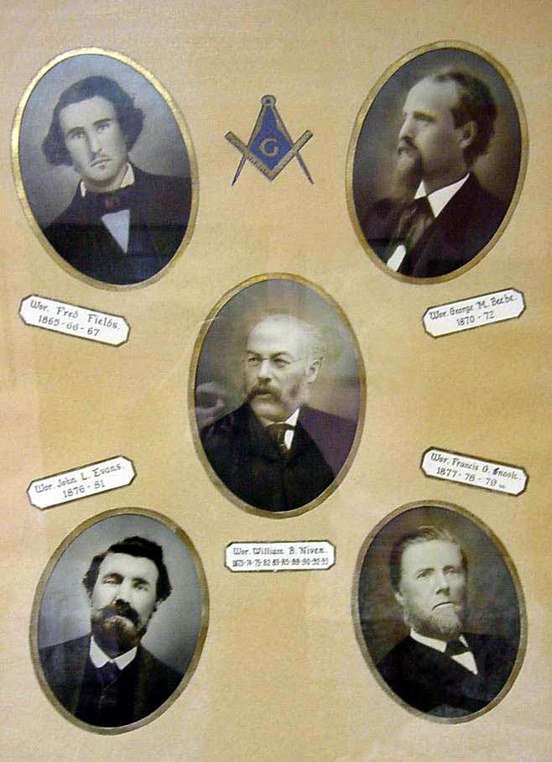
Masters of Monticello Lodge
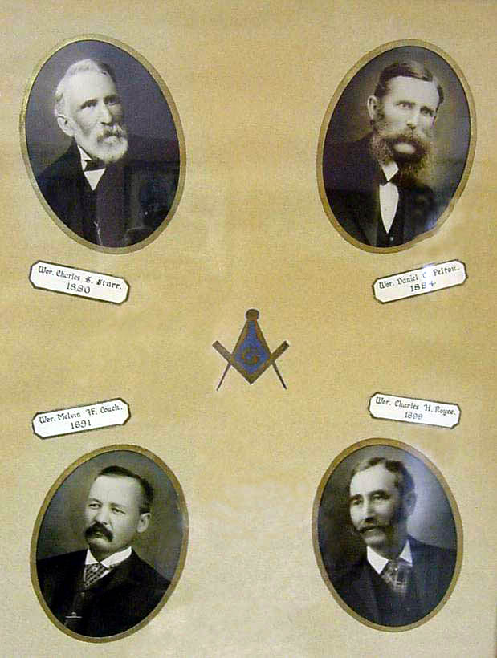

Erection of a temple was laid over with the expectation of making definite plans upon expiration of the lease. Beebe was called to the Assembly, however, and George R. Kelton was elected. Kelton was a wagon maker and painter and while he was a good ritualist he nevertheless did not have the organizing ability of Beebe. The lodge had planned to complete plans for the building of the temple during the following year when Beebe said he would serve. Plans were well under way on February 23, 1872, when a disastrous fire struck Monticello. This fire took place only six months after the serious fire of August 1871, and was succeeded by another in April, 1872, which destroyed the newspaper office of Bro. Beebe.

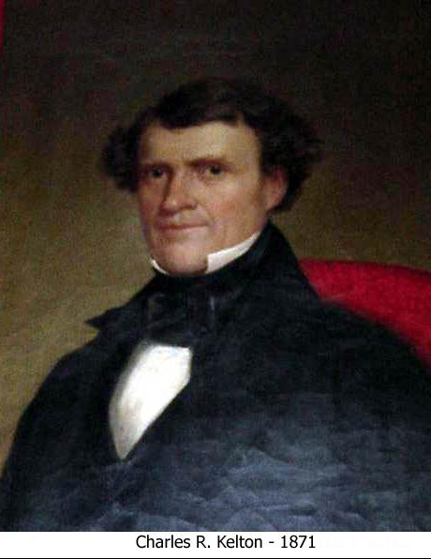
Serving the longest number of years as Master was William B. Niven, a Monticello lawyer, who succeeded George M. Beebe in 1873. After completing that year he served in 1874, 1-875, 1882, 1883, 1885, 1889, 1890, 1891; 1892 and 1893. He served through the lodge's most trying years which lead up to the panic of 1893, when agricultural depression, farm mortgages, reckless railway financing and unsound banking in the United States contributed to the crisis. The panic began in the spring of 1893 with the failure of the Reading Railway and the collapse of the National Cordage Company, one of the numerous examples of reckless trust financiering into which large banks had also been drawn. It was during one of these many years he served (1875) when the new Masonic Temple in New York City was dedicated. Records available do not indicate that any of the members of Monticello Lodge attended.
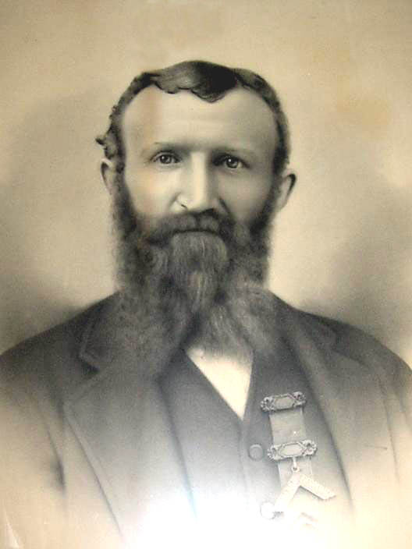
Robert J. Brome, 1886, ‘87, ‘88, ‘94, ‘95, ‘96
Robert J. Brome, the tenth Master of Monticello Lodge, served for six years. He conducted a boarding house (the Branlip Hotel near South Fallsburg) for a number of years.
There were no automobiles when he was Master and lodge attendance was not great. This, however, was not due to any fault of Bro. Brome. While he was Master and for many years after that he would drive his horses and buckboard from his home, picking up brethren along the way.
Both he and his successor, Robert McNickle, are remembered by our older members as the brothers mostly responsible for keeping the lodge from going into inactivity.
He enjoyed participation in lodge work and was especially fond of his role in the third degree, which required little or no make-up.

He was Master on October 31, 1885, when the Most Worshipful Grand, Master of the State of New York sent out a circular letter to the craft calling their attention to the fact that the sum of $485,000 was still due and if permitted to run to maturity would incur an expenditure of $165,000 for interest. Bro. Niven addressed the lodge on matters pertaining to the Hall and Asylum fund and proposed that the lodge should proceed to take action toward paying its portion of the debt. He pointed out that if the lodge paid its full assessment at that time it would result in a reduction in Grand Lodge dues and eventually result in a saving to the lodge. It is known that collections were made for this fund but as to the amount no record is available.

Evans, Snook, Starr and Pelton

During the years from January 1, 1873, to December 31, 1893, when William B. Niven did not serve as Master, John L. Evans, F.G. Snook, C.G. Starr, D.C. Pelton, Robert Brome and Melvin Couch served.
John L. Evans, a merchant who conducted a hardware store at the corner of Oakley Avenue and Broadway, served during the year 1876 and in 1881.
On July 4, 1876, the lodge, under his direction, celebrated the centennial anniversary of the signing of the Declaration of Independence. The lodge room was appropriately decorated for the occasion and special exercises were conducted. A page in the minute book was dedicated to the meeting. We have been unable to determine the exact order of the program because the lodge's records were all destroyed in the fire which destroyed the temple in 1909.
Bro. Evans was friendly, very accommodating and generally liked in this community. After many successful years in the hardware business here he sold his business, demitted from Monticello Lodge and moved to Ellenville.

1877-78-79

F.G. Snook (Sevenoak) was, a man of unusual intellect as well as an earnest and enthusiastic Mason. Monticello Lodge was under his leadership for three years (1877-78-79), and during these three years lodge ritualists who had been careless with pronunciation and delivery were schooled in their work as never before.
Snook was considered one of the best a speakers of the day and, in keeping with the style of the day, used no notes. Once while addressing the brethren he failed miserably In pronouncing a word. Instead of "skipping it" as our great speakers of today would, he paused In embarrassment and explained that while concentrating his speech his memory had lapsed into his boyhood idiosyncrasies.
During his mastership Snook was owner and principal of the Monticello Academy. He affiliated with Monticello Lodge in 1865. Prior to coming to Monticello he had been principal of the Liberty Normal School Institute.
His private Monticello Academy was continued under a special act of Legislature and was subject to the visitation of the Board of Regents and the control of a Board of Trustees. Boarders were required to study from six until eight in the evening and from seven until eight in the morning.
He was stern in the school room and his austerity was actually as great in the lodge room.
He allowed no idle talk, and carefully guarded the interest of the lodge.
Upon discontinuing the Monticello Academy he moved to Hoboken, N.J. The old academy was then transformed into what was known as the Feiner House. The property was later purchased by the County of Sullivan for $16,000 and the buildings were dismantled.

1880

C.S. Starr was a brother of the first Master of Monticello Lodge. He was raised in a lodge in Illinois in the early 50's and affiliated with Monticello Lodge in 1863. Before his death on November 30, 1917, he was the oldest living member of Monticello Lodge. Bro. Starr served not only as Master in 1880 but was also trustee for a number of years.
Although no important Masonic events and not even a funeral service was necessary, during the year 1880, Bro. 8tarr served with credit to the fraternity and won respect for himself in the minds of the brethren whom he loyally served in the capacity of trustee in later years. He was trustee when the present temple was erected and Masons who knew him say that it was perhaps due to him more than any other one man that the lodge had a home in the latter part of the nineteenth century and has a home today.
As he served his lodge well so did he served the community. As one of the proprietors of the Monticello tannery, he was considered by his employees as exacting but nevertheless human and understanding.
His organizing ability was recognized by the Sullivan County Board of Supervisors when the present Election Commissioner's office was created in 1911. He served as president of the Board until his death.
Although Daniel Comfort Pelton was not the first of his family to make worthy contributions to the fraternity he nevertheless was the first Pelton in Monticello to wear the purple of the craft.
He served as Master in 1884 and for years was owner of the building in which Monticello Lodge convened.
Bro. Pelton was born at Sackett Lake on March 12, 1839, attended the district school until fourteen years old and then finished his schooling at the Monticello Academy. He followed his teaching vocation for a number of years, having schools at Barryville, Rock Hill, Mongaup Valley, and other places.
About twelve years before he was Master he purchased property which is where Bogner's meat market is now located, and opened a boot and shoe store. It was over the store where the lodge held its meetings.
His service as teacher, school trustee under the old system, and a member of the newer Board of Education gave him a Master's requisites and so nobly did he perform his duties that recognition soon came from Grand Lodge.
He was a man who firmly held to his own convictions and these he asserted with such force and vigor as to sometimes shock the more timid of his associates.
During his funeral services all business places in Monticello were closed.
Robert J. Broome ended his sixth year as Master in 1896 and was succeeded by Robert McNickle, superintendent of the Monticello tannery. Bro. McNickle had been a frequent visitor of neighboring lodges throughout the county and had a thorough knowledge of the ritual. In addition to a good memory and accuracy in his lodge, work he was a good planner. The clamor for a new temple had been heard for years but no Master had taken the initiative to build. The lodge was then meeting in rooms located over the Daniel C. Pelton shoe store. It was in these rooms that Reinzi Stratton, our fifty-year member; John Brown, our oldest living Past Master; Andrew J. Hammond and Arch Rosenstraus received their three degrees.
The Pelton building was a frame structure with a French roof. The lodge-room windows, of which there were few, were cut through the hip-shaped roof. In the winter the brethren found it difficult to keep warm and in the summer the nearness to the roof provided little opportunity for ventilation and heat penetrated almost to a degree of suffocation.
Two old-fashion chunk stoves provided heat and consumed large quantities of wood, which was usually provided by the brethren.

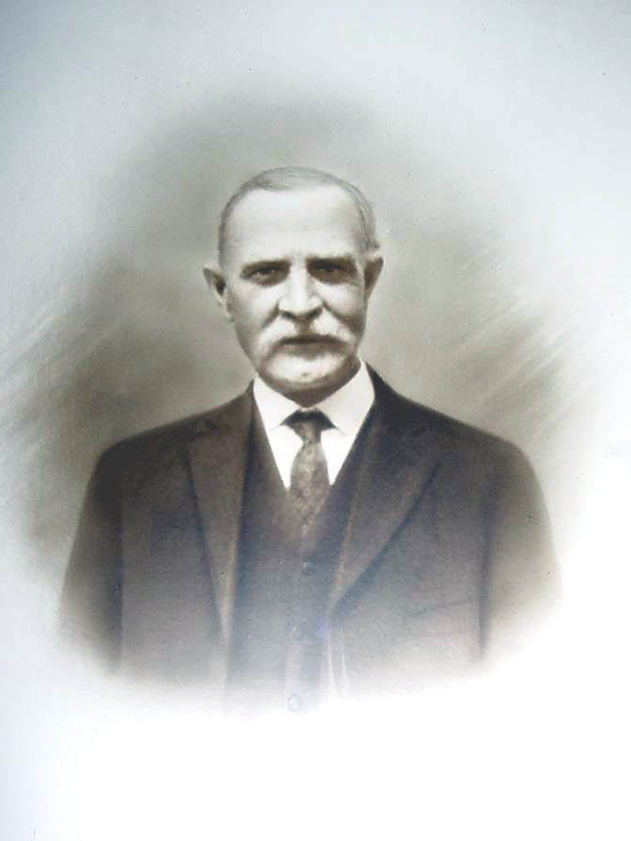
ROBERT McNICKLE
for years the leading spirit of Monticello Lodge, served while the first temple was being built. He had a thorough knowledge of the ritual and was devoted to Masonry. On many occasions in the absence of officers, he is said to have gone from one lodge station to another ably performing the work of the absentees.

The new temple was completed in the early fall of 1898 and it was dedicated with an imposing ceremony on October 29, 1898.
William A. Sutherland, Grand Master, and his staff met in the lodge's magnificent reception room at 8 p.m. and the lodge was opened in due form. Assisting the Grand Master during the ceremonies were Grand Treasurer George W. White, Grand Marshal Isaac Frome, Grand Sword Bearer Jacob Heidt, Grand Tiler Andrew Ferguson, Acting Grand Chaplain the Rev. P.C. Creveling, Acting Grand Senior Warden Charles T. Curtis, District Deputy Grand Master of the 16th District.
Also assisting were S.E. Wenzel, Master of Delaware Lodge; Acting Grand Junior Warden Justice Arthur S. Tompkins, District Deputy Grand Master 13th District; Charles Smith, District Deputy Grand Master 18th District; N.B. Wood, District Deputy Grand Master of the Sixth District; Walter M. Hand, District Deputy Grand Master of the 28th District; Jesse T. Durland, District Deputy Grand Master of the 27th District, and Henry C. Gillespie, District Deputy Grand Master of the District.
The brethren were seated in the main lodge room and the Grand Marshall announced the entrance of the Grand Master and the Grand Lodge officers. The brethren rose and the officers of the Grand Lodge entered. They were received with Grand Honors.
After prayer and symbolic ceremonies the Grand Junior Warden presented a vessel of corn as an emblem of nourishment.
The Grand Master said, "In the name of the great Jehovah, to whom be all honor and glory and praise, I do solemnly dedicate this temple to Freemasonry".
Then followed the same ceremony in the pouring of oil and wine which was followed by a benediction by the Acting Grand Chaplain.
Grand Master Sutherland then delivered an address replete with learning and eloquence. He set forth the high purposed of the order.
The exercises closed with a benediction, after which a banquet was served in the spacious parlor which adjoined the lodge room. This room was in the front part of the building.
Visitors were present from Livingston Manor, Mongaup Lodge of Liberty, Delaware Lodge of Callicoon, Jeffersonville Lodge and several other lodges, including Wawarsing Lodge of Ellenville.
Bro. McNickle's officers were John E. Brown, Senior Warden; Blake H. Bates, Junior Warden; Walter G. Prince, Secretary; William B. McMillan, Treasurer; K.M. Reynolds, Tiler; Derwood B. Tuttle, Senior Deacon; George Hill, Junior Deacon; John C. Taylor, Senior Master of Ceremonies; Silas Demerest, Junior Master of Ceremonies; John Selleck, Chaplain, and Blake H. Bates, Organist, and Seth G. Carpenter and John C. Taylor, Trustees.
A special communication for installation of officers was held Tuesday, January 8, 1901.
A delegation including George Waller, George Armstrong, K. M. Reyno1ds, John Brown, J.C. Taylor, S.W. Demerest, Blake H. Bates, George O. Fraser, A.J. Hammond, W.G. Prince and D.B. Tuttle attended the convention of the Tenth Masonic District which was held that year at Walton on January 11 and 12. Fifteen lodges were then in the district and the membership of all of the lodges in the, district totaled 1,382, of which 104 attended the convention.

1899

It was only a short time after the temple dedication when Charles H. Royce was elected Master, Bro. Royce was then 56 years old and had been a member of Monticello Lodge since September 9th, 1894. At that time he was one of the most popular and influential men in Sullivan County. He had already served as clerk of the Sullivan County Board for eleven years. He had served with the U.S. Treasury Department in Washington and as Consul to Prague in Austria. The latter position he held for five years. He served during the Civil War, entering the army as a private, and he was several times wounded and received various promotions in recognition of his gallantry. At the end of hostilities he held the rank of captain. In 1867 he was promoted to the rank of Major by brevet.
Bro. Royce was a lawyer by profession and was graduated from the Liberty Institute, Eastman Business College and the Columbia Law College at Washington.
He had a very successful Masonic year, adding to the lodge roster as well as to its treasury.
He died on July 19, 1903.
In August of the same year a highly successful Masonic fair was held. The fair's success was evidenced by one of the largest crowds ever brought to Monticello up to that time. The spacious Music Hall was artistically decorated for the occasion and the dozen or more booths were managed by more than thirty men and women.
Attracting crowds from the far ends of Sullivan County were souvenirs of all descriptions and booths displaying candy, sportsmen's equipment and game, household equipment and supplies as well as a variety of novelties, including a fish pond, Japanese bazaar, Egyptian bazaar and a gypsy camp. Receipts for the first day were $131.57.

Royce - 1899

In August, 1899, Monticello Lodge conducted another highly successful fair at the Central Music Hall in Monticello. The fair opened on Tuesday, August 8, 1899, and continued through August 11.
Many valuable articles including a kitchen range, lamp, set of dishes, table covers, table, chairs and other items were donated by businessmen of Monticello.
The Citizens' Band of Monticello was employed for the second night of the fair and on Thursday evening an excursion was run from Port Jervis. Accompanying the trainload of people was the Erie Band.
Friday was White Lake day and Saturday marked the ending of one of the most successful fairs held up to that time.
Bro. Royce reported receipts of $1,125 for the week. This amount was $50 more than receipts the year before.

1900

At the turn of the century Monticello Lodge elected George Eldridge Waller its Master. He was then thirty-one years old. He had a very successful year as Master despite his personal business reverses which resulted in his dissolving a partnership with his brother, J. Hammond Waller, and discontinuance of his work as publisher and editor of the Sullivan County Republican.
The brothers had leased the newspaper business from their father, Major John Waller, who founded the Sullivan County Republican in May 1856.
W. Bro. Waller had spent his boyhood in Monticello and with the exception of a short period when he attended, Susquehanna Collegiate Institute he also spent his early days of manhood here. He was well acquainted through the county and the fact that he had made many friends in Masonic and other fraternal and business organizations was demonstrated at his funeral, which was conducted by Masons on the Sunday following his death, which occurred on September 25, 1901.
He and his wife, the former Miss Lenora Pitcher, daughter of Captain H.A. Pitcher, whom he married in May 1892, were living in New York City at the time of his death.
Wor. Bro. Waller's body was brought to Monticello for services at the Episcopal church, which were in charge of the Masons. Sixty-eight Masons appeared in the line of march to the cemetery. Other organizations were lodges from Ellenville, Liberty, New York City and Mt. Vernon. The Neptune Hose Company, of which he was once foreman, and the Mountain Hose Company appeared with members in full uniform. Masons included among the pall-bearers were Andrew J. Hammond and John Armstrong. Wor. Brothers William Carpenter, Walter Smith and S.G. Osborn were among the flower carriers.

1901

The year 1901 again presented a perplexing problem for those who were planning the future and welfare of the lodge. The lodge had new members who were young and enthusiastic but nevertheless their experience with ritualistic work, which at that time was taught from mouth to ear, was insufficient to qualify them as Master. Wor. Bro. Waller had moved to the city. Wor. Bro. Robert T. Broome, one of the pillars of the lodge, who had already served six years guiding the lodge through years when the effects of the Cleveland panic were still in evidence and years before that when lodges were finding it very difficult to operate, could no longer serve.
The only choice was between choosing an inexperienced brother to head the lodge or to fill the vacant chair with a Past Master. Wor. Bro. Robert McNickle was the only one to volunteer. He had distinguished himself as Supervisor of the Thompson Township and was foreman of Monticello tannery, which was then employing about sixty men. Many of the brethren were employed there. Wor. Bro. McNickle was determined to have the degree and other work of the lodge property executed and on many occasions occupied his own chair for the Master's work and, when completed with his part, would go to the chairs of other officers to execute their work when they were absent. He occupies a place of honor in our lodge and those who knew him do not hesitate to say that he was a Mason, worthy and well qualified - a Mason who laid down his working tools to hear the welcome words, "Well done my good and faithful servant."
Aside from routine lodge work, Wor. Bro. McNickle reported a successful year in charitable work. His only funeral that year was conducted in December, 1901, for George O. Fraser, a former County Clerk, who died on December 3, 1901.
He served ably as Deputy Sheriff for three years under George D. Pelton, who was a Past Master of Monticello Lodge and, District Deputy. Among his contributions in public life was a vote in the Board of Supervisors which blocked a move to designating Liberty as the county seat. He was trustee of the village of Monticello in 1895 when the water supply system we now have was under construction and was a vestryman of the Episcopal church.
He had been a Mason only three years when he became Master. He was a Patron of the Kiamesha Chapter of Eastern Star and one of the charter members.
His funeral was attended by a large number of Masons who marched in a body from the lodge rooms to his house where services were held by Masons.
He was born in Roosky, County Tyrone, Ireland, on January 3, 1853, and came to America when 19 years old. He had been connected with the tannery for 30 years.

1902

In 1902, with the election. of Bro. John H. Brown, a young and energetic Master, who was ably assisted by a staff of officers with unusual ability, the lodge saw the fulfillment of many things for which Masons had been wishing for years.
H. Lynden Hatch was the new Senior Warden; D.B. Tuttle, Junior Warden; Benjamin McMillan, Senior Deacon; Hiram Harding, Junior Deacon; John C. Taylor, Senior Master of Ceremonies, and Silas Demerest, Junior Master of Ceremonies. Tuttle, Taylor and Demerest were much older than their superior officers but nevertheless were not wanting in the requisites of officers.
The officers were prompt and attentive and the old story of “no officers and poor work” was past history.
New ideas and new plans were now being laid before the brethren. These ideas and plans in contrast to the discussions and concern about lodge inactivity which had featured the meetings of preceding years, brought new interest and a better attendance.
Popular in those days were festivals known as "The Kirmess". The Kirmess or church fair derives its name from the old Germanic words Kirch-messe, meaning "Church-ale", referring to that portion of the brew and village given as, a tithe to the churches. A tithe to the Monticello Lodge was considered by the brethren as fitting and necessary. The Masonic Temple, completed and dedicated in November 1898, was a lovely and imposing structure but was still encumbered with debt.
Miss Lila Stewart, a former Monticello resident, was then winning fame throughout the country as the promoter of Kirmesses and Carnivals. Her services were sought and arrangements were completed during early summer 1902 for a Kirmess week.
Bro. Hatch devoted a full week doing nothing other than to help execute plans for the festival, which was directed by Miss Stewart.
With more than 175 local and out-of-town people participating, the Kirmess opened at the Palatine Music Hall on August 5th, 1902. The festivities, which continued through August 9th, attracted thousands and netted the lodge $2,200. It was considered one of the most brilliant and most successful events of its kind ever given in Monticello.
The attendance of 700 on the opening night surpassed the fondest expectations. Palatine Hall was transformed with beautiful robes and artistic decorations more brilliant than anything seen before in Monticello. Circling the hall were spacious and prettily decorated booths where everything that the most fastidious taste could desire was offered for sale.
The flower booth was completely filled with fragrant cut and potted flowers and palms and was decorated with evergreens, laurels, etc. Women assisted their Mason husbands and friends. Mrs. M.C. Duryea was superintendent of the booths. Her assistants were Mrs. B.S. Johnson, Mrs. J.W. Coates, Mrs. J.P. Roosa, the Misses Harriet Jones, Harriet Rundle, Louise Bush, Mildred Bennett, Agnes Fairchild, Dorothy Diehl, Miss Menner, and Judge George H. Smith, Messrs. H.A. Glennie, Dehial Decker and J.P. Roosa.

Masters of Monticello Lodge
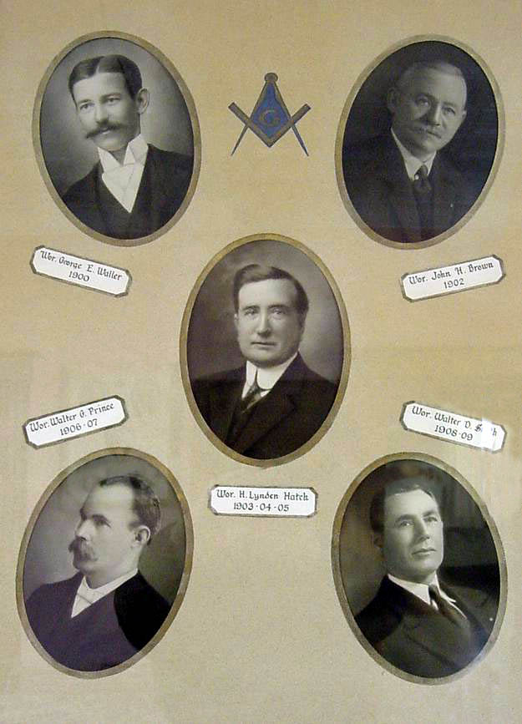
Masters of Monticello Lodge
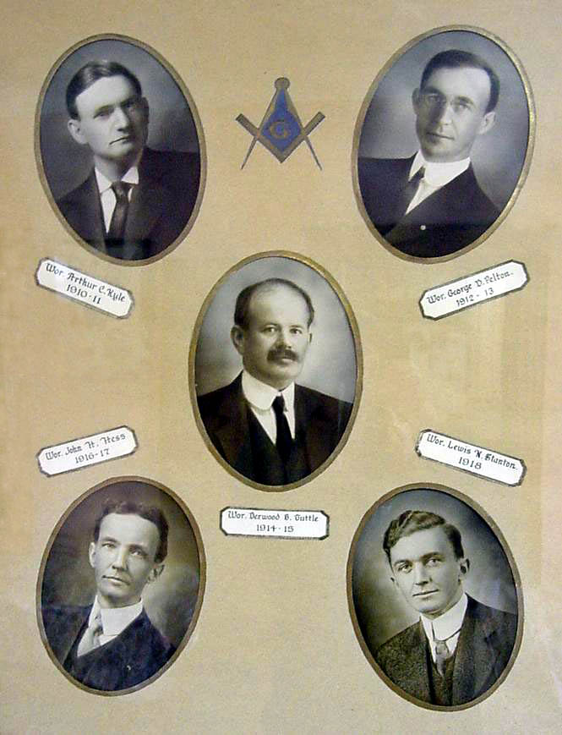

The country store and post office booth combined was unique and attractive. On sale at this booth was everything from a pair of shoestrings to a barrel of flour. Some of the signs displayed on the "store" were, "Love letters and kisses taken with molasses at reduced rates", "Tooth picks and pick ax", "Shoestrings and string beans", "Shoes and salt", etc. The decorations were of corn, oats and pumpkins. The superintendent was Mrs. William McMillan. Miss Annie Crandall was postmistress. Her assistants were Mrs. J.A. Cauthers, Mrs. K.M. Reynolds and Ben McMillan.
The smokers' wigwam was for men only. The entrance was through a pine grove which was lighted by subdued colored lights. Inside the decorations were Japanese lanterns and the booth was filled with divans and large comfortable chairs.
This was the only place where tobaccos were sold and smoking permitted in the hall. Among the articles disposed of by chance at this booth were boxes of excellent cigars, meerschaum pipes, cigar holders and a leather hanger. This resort was very popular with smokers. The superintendent was Mrs. Jean Caldwell, who was assisted by Mrs. B.B. Williams, Miss Mary D. Niven and others.
A beautifully decorated candy booth was superintended by Mrs. Charles G. Burns, who was assisted by Mrs. D.W. Sherwood, Mrs. N.W. Thompson, Mrs. William Mapes, Mrs. A.P. Bennett, Mrs. H. Harding, Mrs. Sadie Saxton, the Misses Grace O'Neill, Julia Starr, Mary Turner, Louise Armstrong, Jennie Smith and Mrs. E.R. Wright and, Mrs. F.A. Starr.
The fancy booth was superintended by Mrs. B.H. Lefferts, who was assisted by Mrs. Robert McNickle, Mrs. W.H. Hand, Mrs. G.H. Mitchell, Mrs. W.B. Niven, Mrs. C.S. Thornton, Mrs. M.H. Couch, Mrs. W.H. Melka, Mrs. A.G. Stafford, Mrs. G.H. Bullard, Mrs. J.R. McDonald, Mrs. G.L. McLaughlin, Mrs. Pettit, the Misses Margaret VanNette, Ethel Strong, Helen Strong and Jennie Dann.
The soft drink booth was superintended by Miss Mabel Royce, who was assisted by Mrs. G.L. Hatch, Mrs. Robert Bradley, the Misses Grace Mitchell, Fannie Stoddard, Isabelle Miller, Beatrice Miller, Lulu Bradley, Catherine Watts, Alice Royce, Lorena Garaghty, Messrs. Blake H. Bates, H. Lynden Hatch, Walter Smith, and Burton Royce.
The refreshment booth was superintended by Mrs. LeGrand Morris, who was assisted by Mrs. H.F. Holmes, the Misses Jessie Broome, Hatty Garner, Jessie LeRoy, Annie Rundle, Mrs. John Selleck, Mrs. A. Dinn, Mrs. John Yeager, Mrs. Samuel Mearns, and the Misses Hall, Mrs. Joseph Engelmann, Mrs. G.W. Rockwell, Mrs. W.W. Williams, Mrs. E.A. Rockwell, Mrs. George Bush, Mrs. R.E. Bradley, Mrs. Minnie McNeeley, and Mrs. Engham.
The first Kirmess number was the mirror dance of the troubadours. "Julie", while preparing for the gala day festival, hears the serenade and throws a rose from the window to the supposed favorite one. Then with the aid of a false mirror and in cooperation with "Hortense" rehearses a trick for the amusement of royalty. The trick is discovered by the sudden entrance of the two serenaders. The four join in a dance until by the entrance of numbers of their friends the gayety continues.
The serenade (Love's Sorrow) was sung by John V. Ennis in a very pleasing manner. The mirror dancers were the Misses Beatrice and Isabelle Miller, who executed the movements with such perfect grace and unison that the mirror effect was complete.
Other dances included the Hungarian Gypsy dance, the Hornpipe dance, the Dutch Wooden Shoe dance, the Carnival dance, the Serpentine dance, the Scarf dance, the Scotch reel, the Dance of the Summer Girls, the Spanish dance, the Indian dance, the Dance of Fairies, Cinderella Gavotte dance, the Dutch reel and the Flower dance.
On Friday evening of the carnival week a special train brought over 200 people from Port Jervis. Every night brought an increase in patronage. Saturday night more than" 1,500 people were present.
One of the interesting events of Saturday night was the final voting for the most popular dance, which was won by the Indians, who received 2,078 votes. Next highest was the Carnival dance, with 1,720 votes. For each vote the voter paid five cents.
The officers of Monticello Lodge were kept busy with rehearsals for several weeks but they were well satisfied with their reward. Rehearsing took place in the lodge refreshment rooms which were located in the front part of the building.

1903

In January 1903, Masons of Monticello Lodge witnessed the installation of a Master who was to serve three years with distinction and credit to the lodge and was later to become Deputy Grand Master for the 10th Masonic District.
Brother Hatch was only 25 years old when elevated to the Master's station and still holds the record of being the youngest Master ever elected by the lodge.
His unusual organizing ability and planning won for him a place of respect in the hearts of his brethren which has continued throughout the years. He served as senior Warden during the highly successful Kirmess of 1902 when a large part of the temple debt was retired and had the honor of being identified as the youngest Master of the State of New York when he attended the annual Grand Lodge convention in June 1903.
Bro. Hatch's conduct of office was so satisfactory during the years 1903 and 1904 that he was prevailed upon to serve during the year 1905.
On July 19, 1903, the death of Wor. Bro. Charles H. Royce was announced. Bro. Royce had been suffering for a long time with cancer of the face. The funeral was held on Tuesday, July 21, with 124 Masons in attendance.
Bro. Royce was born in the Town of Bethel on June 13, 1844, and in 1871 he was married to Miss. Marrietta Hamilton Bushnell, daughter of the wealthy Munson L. Bushnell of Monticello. He spent his honeymoon in Prague, Austria, where he was Consul for the United States Government.
At Prague he entertained many distinguished Americans and dignitaries of foreign countries. Among the Americans were General Sherman and others. Many from abroad and out of the county were present at his funeral to testify as to their friendship and esteem for the deceased.
Masons attending were from Ellenville, Chapter of Royal Arch, the Delaware Commandry of Port Jervis, and every Blue Lodge throughout the county was represented.
Masons in Newburgh were represented by Joseph Embler, Ben Quinlan and J.B. Quinlan. Hoffman Lodge at Middletown was represented by U.T. Hayes and Edward VanDuser.
Pallbearers were his old Masonic Companions, George Rockwell, John P. Roosa, George Hill, Seth G. Carpenter, George Armstrong and D.S. Avery.
Wor. Bro. Hatch had a thorough knowledge of the, ritual and very capably delivered the Masonic funeral oration. He was assisted by the Rev. Mr. VanRoesen.
At the conclusion of the services his close friend and brother, John P. Roosa, moved to the head of the casket and said:

"My Brothers and Friends:
"In this sacred city of the dead we have today paid our final tribute of love and respect to our departed friend and brother. It is hard for us to realize that he who but a short time ago was so strong and to all appearances had a long lease of life before him should be stricken, and laid cold to death. It has been apparent for some time to the friends of our departed brother that the sands of life were nearly run. But with that spirit of bravery and energy which characterized his life he made a desperate battle. To those of us who knew him personally his memory will be a pleasant one. The reputation he made upon the field of battle will never die. Untarnished by time and to it we pay our homage in this tribute to his memory. He evaded no peril but faithfully and loyally performed the work allotted to him. He never turned his back upon an enemy or friend. There is something which suggests to us thoughts of another world in a head shrouded in white and hence there is that veneration for grey hairs which has become noticeable among the virtues of our race. But when death enters the tanks of those of fresh maturity he seems to come before his time to gather today the harvest of tomorrow. But as it is with our departed brother so must it be sooner or later with you and me. Nothing is left for us as we drop our tears of sorrow but to cherish his memory and to remember that our end and object in life should be to perform the duties of our life work well. At this hour We pause to do honor to his memory and as we try to convey to the hearts of those who mourn him most our sympathy in their great sorrow, let us believe in the truth of the sentiment:

"There is no death! What seems so is transition;

This life of mortal breath

Is but a suburb of the life elysian
Whose portal we call Death.’”

1904

Wor. Bro. Hatch's second year saw the birth of the Kiamesha Chapter of Eastern Star. And as the members of the Eastern Star have worked diligently with the Monticello Masons for nearly two score years we would be ungrateful if we were not to give them recognition in this history.
Kiamesha Chapter No. 309 was instituted on April 5th, 1904, by Grand officers of the old 5th district of the Star, which comprised Ulster, Orange and Sullivan counties.
Organization of the chapter was the result of an appeal by Miss Louise Armstrong and Mr. and Mrs. Alexander J. Glennie to the Grand Chapter for the formation of an Eastern Star chapter in Monticello.
The chapter was formed with fifteen more than the twenty necessary for organization. Seven of the members were Masons.
Officers chosen for the first year were Mary C. Glennie, W.M.; Alexander J. Glennie, W.P.; Kathryn Rockwell, A.M.; Emma C. Holmes, Treasurer; Flora A. Smith, Secretary; Sadie M. Selleck, Cond.; Nettie M. Bradley, A. Cond.; Hattie F. Dunn, Chaplain; Lizzie E. Prince, Marshall; Grace E. McLaughlin, Organist; Violet H. Burns, Warden; Thomas Garner, Lieutenant; Rose Beecher, Adah; Eleanor Louise Armstrong, Ruth; Fannie M. Mitchell, Esther; Mildred McNickle, Martha, and Marrietta St. John Avery, Electa.
The annual dues were $2, the initiation fee, $3, and application fee, $2, and the first and third Monday of each month were designated as the meeting nights. In 1927 the dues were increased to $4 and the initiation fee to $10.
When the Kiamesha Chapter was formed there was only one other chapter in Sullivan. That was the Sullivan Chapter at Livingston Manor.
Contributions made by the Eastern Star have been liberal since the chapter was organized. When the temple burned in 1909 they assisted greatly in raising funds for purchasing carpet and other lodge fixtures.
The most depressing event during Bro. Hatch's Mastership was the Masonic trial of Delbert Sherwood. Sherwood, a, native of Livingston Manor, was married to Lillian Royce, a daughter of Past Master Charles H. Royce. He was accused of “abusing his wife while under the Influence of intoxicating liquor.”
At the trial, held during the early part of 1904, Sherwood was defended by Melvin H. Couch. He offered little in defense of his client was found guilty and expelled in March 1904.
In 1906 Walter G. Prince, a book keeper and clerk at the lumber concern, Stephen Trowbridge and Son, was elected Master. Lodge meetings started with a first degree which was conferred upon Charles W. McClurg, a Hurleyville chef. During the year eight were admitted to membership, eight of them having been raised.
Prince was re-elected in 1907 and had another successful year raising eight and affiliating one. Bro. Prince was regular in attendance and popular among the members of the lodge. His ability and loyalty won for him in later years the lodge secretaryship which he held for two years. Bro. Prince moved to Swan Lake a number of years ago where he purchased a farm which he is still operating.
Elected Master in, 1908 was Walter D.B. Smith, a carpenter and contractor, who also served during the year 1909. Upon him fell the responsibility of providing lodge quarters after the disastrous fire of 1909 had destroyed the Masonic Temple and a large part of the business section in Monticello. The fire occurred in August 1909, and the Masonic Temple, which was of brick and about the same style of construction as the present building, simply melted away in the fierce heat which developed around it as the old National Union Bank on the corner and the small brick Surrogate's Court building next door went down before the flames.
One of the features of the new Temple built after the fire were metal shutters designed to keep the building protected against a similar disaster. The only thing saved from the old lodge records was the treasurer's book. The old building's cornerstone was incorporated in the new building, which was completed and put in use in 1910.
The cornerstone laid for Sullivan Lodge No. 272 at the corner of what is now Pleasant Street and Broadway in 1829 was suggested for the new structure in 1909.
The large stone weighed 940 pounds and contained an 8" x 10" cavity which was twelve inches' deep. From the cavity was removed a zinc box which had been carefully sealed. It contained only copies of the Republican Watchman, Sullivan County Whig and The Examiner, the latter a York City publication. Dampness deteriorated the old newspapers and their use for record purposes was of little value.
It was a notable occasion when at last the Masons of the village once again had a fine lodge hall in their own building after the somewhat primitive accommodations left after the fire in the business district. There was general rejoicing and not only members of the lodge but many of their friends enjoyed a memorable social evening in the newly completed lodge rooms.
The Masons, like many others forced to face losses of the fire, probably did not find it easy at that time to raise the necessary funds and go ahead but there was never any question about rebuilding as soon as possible on the old site. Almost as soon as the ruins could be cleared away following the August fire, the new building was started and the gradual restoration of the town which suffered nearly a million dollar loss over night was undoubtedly greatly encouraged by the rebuilding of the lodge home.
Many of the Masons had themselves suffered the loss of their business places in the big blaze. But the Masonic Lodge, like other elements of the community, pitched in with might and main to make a fresh start. They never had reason to regret this prompt and effective action. The fine building was completed and the lodge has known some of its most prosperous years since this big fire.
Brother Smith was highly respected in the community and was a leader in the Presbyterian church, where he organized the men's club which today bears his name. He died on April 20, 1934, at the Hamilton Avenue Hospital after undergoing an operation.
Arthur C. Kyle, Sr., was serving the first of his two years as Master when the second Masonic Temple was dedicated on October 10th, 1910.
The Most Worshipful Robert Judson Kenworthy and his staff of officers dedicated the new structure.
The ceremony of dedication was under the able direction of Right Worshipful Joseph Klinck, Grand Marshal. Assisting in the service were R. W. Arthur Bouton, District Deputy of the 16th district; Earl; J. Adams, Grand Senior Warden; John J. McCrum, Grand Junior Warden; the Rev. William R. Watson, Grand Chaplain; Robert A. Stewart, Grand Standard Bearer; James McCourt, Grand Senior Deacon; Albert J. Wilson, Grand Junior Deacon; Joseph McElroy, Grand Tiler; James E. McGiffert, District Deputy of the 13th District; John E. Sparrow, Past District Deputy of the 3rd District; Matthew W. Bronson, Past District Deputy; H. Lynden Hatch, Past District Deputy; J. Floyd Halstead, Past District Deputy of the 13th District; Joseph A. Lawson, District Deputy of the 17th District, and Brothers George W. Rockwell, George D. Pelton, David S. Avery, Harry Keating and Rev. W.I. Stetcher of the Monticello Lodge.
The ceremony of dedication was carried out in an able and impressive manner. As the Grand Lodge formed and took possession instituting a symbolic lodge for the occasion, the Master of the lodge, in an eloquent address, importuned the Grand Master to dedicate the new, temple to its proper usage."
Accepting the appeal the Grand Master, in accordance with ancient rites and usages proceeded to comply with the emblems of dedication at the hands of several officers, did with corn, wine and oil dedicate the building to Freemasonry, Virtue and Universal Benevolence. The Grand Master in his charge spoke feelingly of the situation, expressing his, satisfaction at the great work accomplished in the erection of the new temple, describing the sense of appreciation that must be in every heart to a coming "home". Other addresses were made the request of the Grand Master by Right Worshipful Arthur R. Bouton, H.W. Joseph Lawson, R.W. the Rev. William R. Watson and the Rev. W.I. Stetcher.
A large attendance was present from Mongaup Lodge, Liberty, Port Jervis, Middletown, Mamaroneck and other places.
The cornerstone for the temple was laid in November 1909, with special exercises at St. John's Episcopal Church. The speakers were the Master, Walter D. Smith, and Bro. J.M. Maybe, Sullivan County's silver-tongued orator.
We value our present temple at more than $25,000 and when we consider that Bro. John H. Brown and Henry Washington completed construction of the building in 1910 at a cost of $13,789.21. We can only pause to pay tribute to our trustees who have so ably planned our course.
When the new Master started his work he was confronted with more than the ordinary work of one in his station, it was true that brethren had just completed a new temple to replace the one destroyed by fire but he and the brethren also realized that there were many things within the temple walls which the building contractors did not have in their specifications.
Ralph B. Towner headed a committee which very ably raised funds and purchased the "G". Dr. James A. Cauthers presented a new Bible and with the help of brethren such as they the task of acquiring the necessary lodge equipment became less burdensome.
The announcement that Grand Lodge was refurnishing its chambers came as welcome news to the brethren in 1910 and judicious action of a committee headed by the lodge's venerable treasurer, William B. McMillan, comprised of trustees and the Master, resulted in the lodge's purchasing the used Grand Lodge furnishings at $1,000. This sum was only a fraction of what the equipment is worth. The solid mahogany chairs, benches, altar, together with priceless pillars, decorated with all the splendor of King Solomon so aptly described in the Middle Chamber lecture; the solid brass pedestals and other necessaries have now adorned our lodge room for more than thirty years but still retain their luxurious appearance.
When purchased the upholstering was of red plush. The carpet which also came with the furniture harmonized very well with the other fixtures of the room.
About the time the furniture was purchased H.B. Roosa gave $25. This donation and many others swelled the lodge's treasury and made their financial Condition less embarrassing during those trying times when insurance had covered only $10,000 of the lodge's $25,000 fire loss.
The year 1911 saw the lodge gradually recovering from the stunning blow of 1909. Interest was renewed and contacts both among its members as well as those belonging to other lodges were made. The sympathy of all was offered and willing hands were still eager to work.
H.B. Stratton installed an organ and the daughter of Past Master C.R. Kelton presented to the lodge an oil painting of her father.
The official visit of William B. Hand, the District Deputy, was made that year on December 8.

1912

District Deputy for the following year was Joseph Rosch. He held his convention at Livingston Manor on February 2, 1912, with a sizeable delegation attending from Monticello.
With the election of George D. Pelton. for the year 1912 Monticello Lodge became one of the most active organizations of its kind in the district.
The new Master was energetic and his associations with other lodges and in public life brought many visitors and brethren to meetings.
A minstrel show early that year netted the lodge $273.48.
In the Fall of that year the lodge celebrated its fiftieth anniversary with a large attendance, including Masons from this and adjoining counties of Delaware, Ulster and Orange.
Serving on the Celebration Committee were the Masters, John T. Curtis, William B. McMillen, B.H. Lefferts and Robert McNickle. The celebration was one of the most notable events of the year.
In making his contribution to the lodge in 1912, William Moore, of Sackett Lake, deeded a lake lot to the lodge. This lot was owned by the lodge until 1937, when the lodge held it would be inadvisable to continue ownership with a view of developing it.
Accordingly and in compliance with a clause in the deed the lake lot was returned to its owner.
On September 30, 1912, the Grand Master, Charles Smith, warned Masons that the Fera Organization had been set up in Italy and issued an edict forbidding the members of the Craft from holding intercourse with the organization.

1913

The duties of Master were so well executed during the year 1912 that Bro. Pelton was re-elected for another year. District Deputy George F. Sullard made his official visit that year on February 24, 1913.
The lodge reported a large attendance at a joint picnic of the Kiamesha Chapter of Eastern Star and the Masons held on July 1 at Seth Pelton's at Sackett Lake. Bro. Pelton's friendly attitude won for him many new friends during the year he served and in 1921 he was honored with the appointment to the District Deputyship.

1914

In 1914 the lodge installed Derwood B. Tuttle, who was regarded as one of the lodge's best ritualists. He mastered the Middle Chamber lecture to a degree of perfection and both he and the brethren enjoyed the hours spent in addressing newly made brethren. His delivery was forceful but mastered to a degree of perfection which enabled him to control the attention of all, bringing both laughter and tears.
A printer by trade, Bro. Tuttle was as precise in his duties in the shop as he was in the lodge. His popularity both among Masons and the village band, which he led for many years, made him a lasting friend with all who knew him.
It was George S. Sloan, a close friend of Bro. Tuttle and a member of the lodge, who gave the lodge the valuable antique sideboard which now is in our lodge reception room. Announcement of this gift was made on August 14, 1914, when a resolution of I thanks to the donor was approved. At the same meeting the gift of a Masonic history was acknowledged.
The Master, his officers and brethren were busy during the year 1914. A Masonic fair held during the summer netted the lodge over $1,000. The Master gave due credit to the members of the Kiamesha Chapter of Eastern Star for their cooperation.
During the year eleven members of the lodge died and three were unaffiliated, making a loss of fourteen. Several names had been added that year but the final figures showed a loss and brought the number of members to 218.
When District Deputy Nial Curry made his official visit on October 9, 1914, the degree of Fellowcraft was conferred upon the Middle Chamber lecture and it so impressed the visitor that the story about this incident was made known throughout the district.
Elected again at the end of his first term, Bro. Tuttle served faithfully and devotedly. During the year 1915 organizations, including the Knights of Columbus and Grange, had expressed their desire to rent the lodge rooms but the lodge refused to grant their request.

1916

Succeeding Brother Tuttle was John H. Hess, a telephone executive who was gifted with ability, foresight and a pleasing personality, with these requisites he brought both financial and social progress during the two years he served.
Degree work was a part of nearly all of the meetings for both years. A record was set during the year 1916 when fourteen were raised and two were affiliated. Lodge rooms were redecorated and many other improvements were made.
Bro. Hess and his officers visited regularly at all of the lodges in the county and won a wide Masonic acquaintance.
As the summer of 1916 neared the brethren set a precedent by voting a summer recess. Before that time meetings had been held during the summer.
When lodge opened on September 8, 1916, C.S. Starr, a Past Master of Monticello Lodge, was voted a life member. Bro. Starr had affiliated with the lodge on April 1, 1863, and was then a 53-year Mason. Up to that time life memberships had not been granted.
District Deputy Grand Master G.M. O'Connor conducted the district convention at Hobart on December 13, 1916, with Bro. Hess and his lodge officers attending.
A socially successful oyster supper was served by the lodge on December 13, 1916, thus ending a big year.

1917

The officers who served during the year 1917 were publicly installed on January 12, 1917, by Past District Deputy Nial Curry. Acting as Master was L.C. Payne. a Past Master of Mongaup Lodge, Liberty. The Marshal was Grant Palmer, who also was a Past Master of Liberty Lodge.
Installed for the year were John H. Hess, Master; Lewis Stanton, Senior Warden; John T. Curtis, Junior Warden; W.B. McMillan, Treasurer; W.W. Carpenter, Secretary; Sanford W. Starr, Tiler, and H. Lynden Hatch, Trustee, for three years.
Every Tuesday evening during the year 1917 the lodge conducted a school of instruction under the supervision of John Smith. Bro. Smith was a close friend of Edward M.L. Ehlers, who was the Grand Secretary, and had previously instructed Masons in New York City.
Bro. Smith occupied quarters in the temple and served as Senior Deacon in 1917. He and other brethren were greatly shocked when he learned of the Grand Secretary's death on May 28th of that year and not before had his duty of draping the lodge's altar meant so much to him.
The United States had been at war since April of that year and there were many developments affecting the craft which Grand Lodge could not consider in convention the preceding June.
A special session of Grand Lodge took place on September 10, 1917, with Bro. Hess in attendance. Among the noted Masons who were heard at this session was ex-President Theodore Roosevelt.
Masons were present from every section of the State and were eager to help in arranging a “plan and scope of Masonic service for the period of war.”
After the convention Grand Master Thomas Penney announced that more than one degree upon more than five candidates at a less interval than two weeks would be permissible in cases where a
candidate had actually enlisted, had been drafted or commissioned in the service.
Bro. Hess kept in close contact with the lodge's twenty Masons who had answered the call to arms. He appointed a correspondence committee instructed to write each week to those serving in the war. Serving on this committee were Frank G, Mitchell, Walter G. Prince and W.W. Carpenter.
Dues of the brethren were remitted for the duration. This resulted in a loss of revenue but nevertheless demonstrated the lodge's love and admiration for those serving.
The death of F.G. Snook (Sevenoak), one of the lodge's oldest living Past Masters, was reported on November 5th, 1917.
Snook had moved to Hoboken several years before. Also reported was the death of R.T. Sailman, a former member. He had been killed on the battle front.
Grand Lodge had inaugurated a war relief program which served the same purposes as our present War Chest. H. Lynden Hatch, Lewis N. Stanton and Frank G. Mitchell were appointed to serve on the committee to raise funds for this work.

1918

Elected for the year 1918, Lewis N. Stanton was the first to serve as Master of Monticello Lodge after the 16th Masonic District was changed to the present Delaware-Sullivan District.
Bro. Stanton was a descendant of one of the county's oldest and most respected families and had graduated from Yale College with the degree of LLD shortly before becoming Master.
For a time he was rated as one of Sullivan County's most brilliant lawyers.
As a speaker and trial lawyer he was unexcelled. On many occasions he held the brethren spellbound while dwelling on the subject of Masonry and reviewing the hardships of World War No. I which was near the start of its second year when he was elected Master.
Sons of Sullivan were dieing on the battlefield during his year and many a word of prayer and praise were uttered that year for the 19 members of the lodge who were serving their country. The twenty other soldiers who were then members of Monticello Lodge were: Frank Armstrong, Henry G. Calhoun, James A. Dunn, Luis deHoyos, Herbert E. Hess, Ralph S. Breakey, William Hill, Roy L. Holmes, Rev. Aaron R. Lief, John P. Mapes, Ralph G. Moore, George Y. Palmer, S. Wilson Poley, Ralph L. Smith, Homer S. Silkworth, Harvey J. Tappen, Arthur A. Thornhill, Robert S. York and Elmer J. VanKeuren.
Fifteen other additional names were added to this list at the end of 1919. These soldiers were: Elmer L. Bennett, Floyd P. Brown, Roy F. Carpenter, Harold J. Hitton, Douglas Hill, George L. Hill and James Hill (all brothers of William Hill), Harold E. LeRoy, Charles Levy, A.B. Marshall, Harold J. Millspaugh, Ralph S. Osborn, Benjamin H. Porson, Jay C. Pelton and Harry E. Allen.
Bro. David Mearns, who so heroically served in the Rainbow Division; Stanley Sengstacken; who was in the Army of Occupation after the war; Ralph Coddington, George L. Dann, Stephen Contos and many others who served their country have since become members of the lodge.
The most delightful of all meetings during the year were those after the November 11th Armistice when the brethren came marching back to once again enjoy the fellowship of Masonry in Monticello Lodge.
In later years Br. Stanton's star of success began to set. He lost many of the Masonic friends he had won and business reverses caused him such financial embarrassment that even his lodge dues were too great a financial burden for him to carry. His membership with the lodge ceased and he died at a very early age.

1919

Although the armistice of November 11, 1918, officially ended World War No. 1, most of the pleasure of welcoming home the brethren who had served their country came to John T. Curtis, editor of the Sullivan County Republican, who was elected Master for the year 1919.
Bro. Curtis retired with the satisfaction that the lodge had enjoyed a socially successful year. This reward had come to him in face of post war conditions which were imposing hardships upon the brethren. A war costing $35,500,000,000, including $9,500,000,000 in loans to other countries had been won with great satisfaction to all but expenditures after peace continued on a scale far beyond any previous experience of the country.
Bro. Curtis' association with public officials and other notable residents of the county while serving as clerk of the Sullivan County Board of Supervisors and in other civic capacities won him many friends, among whom was Daniel Downs. County Superintendent of the Poor. Bro. Downs was a frequent visitor and in recognition or useful service he had rendered to the lodge he was voted an honorary member.
A crowded trestle board gave Bro. Curtis and his staff of officers little time for programs other than those which included degree work. During his year two men who were later to become Master were raised and a third future Master was elected to membership. Samuel B. Levy and John Jenkins were raised on May 23, 1919, when District Deputy R.W. Davis made his official visit. Bro. Davis very ably delivered the historical lecture. Fred Golterman was the candidate who was elected to membership.

1920

The retirement of Editor Curtis at the end of the year 1919 came with the election of Senior Warden John S. Mearns, another newspaperman, to the mastership. Bro. Mearns was the youngest Master elected since 1905 and in addition to having a thorough knowledge of the ritual he was energetic and eager to work.
The biggest event of the year was a four-day fair and carnival which the lodge brethren they reported that they had been conducted in July. Receipts of the fair amounting to approximately $900 were a applied on a lodge note and the mortgage as on the temple. This was the last fair to of be held by the lodge.
Bro. Mearns married at an early age while an apprentice printer in the employ of the Republican Watchman. He arranged his hours with his employer so that he could attend high school in addition to performing his regular duties. The oldest of his seven children, now 25 and with the Presbyterian Red Cross unit in England, he started school in the grades before her father received his regents diploma.
Miss Clara Tracy, who had served long and well over a period of 25 years teaching in the Monticello High School, instructed Bro. Mearns in history. One day when she demanded an explanation from her pupil regarding his failure to complete an assignment. Bro. Mearns replied: "I'm sorry, Miss Tracy, but the kids made so much noise that I found it impossible to study." She accepted his excuse, which brought an outburst of laughter such as was never before experienced under her strict discipline.
Bro. Mearns' determination and eagerness to find further light in his lodge and society could not be lessened, however, and he has enjoyed a record of success in both.
Now 48, Bro. Mearns is a valued and trusted employee at Albany, where he revision clerk in the State Senate. In addition to his daughter he has three sons in the service. His oldest son, John, is serving with the Air Corps in South Carolina; Robert D. is now in Palestine and Thomas is stationed in Florida with the Navy.

1921

W.W. Carpenter, who had served for a number of years with great efficiency as lodge secretary and as officer in several of its chairs, was elected Master for the year 1921.
He and his officers, Charles Burns, Senior warden; William Pelton, Junior Warden; John Mapes, Senior Deacon; Fred Golterman, Junior Deacon; Harold Hifton, Senior Master of Ceremonies; Otis Stratton, Junior Master of Ceremonies; William McMillan, Treasurer; John Jenkins, Secretary; William Schroeder, Chaplain, and Blake H. Bates, Organist were installed publicly. After installation the lodge conducted a dance at St. John's Parish Horse.
The year started with a crowded trestle board and remained so until a new Master was elected.
Early in the year the Odd Fellows Lodge expressed a desire to rent the lodge room but the Lodge voted again not to lease their premises. A movement to alter the lodge rooms was launched during that year but was not brought to definite action until 1922.
The lodge and one of its members received honor in June 1921, when the Grand Master appointed George D. Pelton his deputy for the Delaware-Sullivan District. A committee consisting of, William B. McMillan, Blake H. Bates, Walter D. Smith and William Pelton was appointed to raise funds for the Masonic Hospital. These men worked hard and successfully raised a sizeable fund.
The District Deputy called his convention at Monticello on November 29. Arrangements for this gathering were made by Charles G. Burns and Leon Q. Brooks. Bro. Carpenter was a post office clerk when Master. He later served as assistant postmaster and for twelve years was postmaster.

1922

One of the busiest years of the lodge came in 1922 when Charles G. Burns and his staff of officers raised twenty. In addition to this number two affiliated.
As the summer neared and the names of candidates were continually being added to the trestle board Bro. Burns asked for and received special dispensation for raising nine in one class. This set a precedent and not since have so many been raised at one time.
Along with new members came prosperity. On March 10 the lodge committee reported that $745 had been collected for the Hospital Fund.
On April 14, 1922, eleven Past Masters received the certificates In the presence
of an overcrowded lodge room, a District Deputy and four Past District Deputies. The latter were H. Lynden Hatch, of Monticello; William B. Hand, of Liberty; Samuel Fancher, of Walton, and William Parshall, of Port Jervis.
The honored Past Masters included John H. Brown, W. G. Prince, Walter D. Smith, George D. Pelton, Derwood B. Tuttle, John H. Hess, Lewis N. Stanton, John H. Mearns and W.W. Carpenter.
In addition to degree work for new members of Monticello Lodge the third is conferred upon Buthold Mattison for Faith Lodge, of Charleston, Mass.
Extensive improvements were made in the lodge rooms, which cost $175. Of this sum, the O.E.S. paid $150.
The O.E.S. during the year had netted and $23.70 from a chicken supper and $58.85 from a food sale. The difference between the total of these two sums and the amount they gave to the lodge was taken from their treasury.
Bro. Burns Is a native of Oakland Valley, Sullivan County, and the son of Fred W. Burns, a blacksmith and Civil War veteran who was raised in Monticello Lodge in 1864. Bro. Charles Burns' mother died when he was eight. He lived with his mother's father, John McMillen, until he was a young man.
Bro. Burns was District Deputy in 1936-1937. He was popular and rendered great Masonic service both while Master and District Deputy. He still is very much interested in lodge work and a year and demonstrated that he still can do lodge work when he acted as Master for the third degree.
The only special communication of the year was held on August 10th, when the lodge assembled and observed a period of mourning, and prayer for Bro. Warren G. Harding, President of the United States, who died on August 2nd.

1923

Following the years of plenty under Bros. Curtis, Mearns, Carpenter, and Burns came a year of famine as far as new members are concerned. Although petitions of worthy citizens were presented there still remained those from the old school who were both satisfied and determined to keep certain individuals out.
During the year several petitions were presented only to be rejected, and finally no petition received the unanimous approval of the brethren.
This condition brought two factions into existence and finally a proposition for forming a new Monticello Lodge was presented.
Special notices were sent to the brethren and of the 92 ballots cast 69 were again the proposition and 23 were in favor of it.
Bro. Pelton's devotion to the craft was manifest and his knowledge of the ritual was thorough. He sought to do good wherever possible and the minute book indicates that he ended his year with his work well done.
Officers for the year 1923, other than the Master, were Fred L. Stratton, Senior Warden; John P. Mapes, Junior Warden; Fred Golterman, Senior Deacon; Henry E. Miller, Junior Deacon; William B. McMillan, Treasurer; Ralph Pelton, Secretary; James Hindley, Senior Master of Ceremony; Ralph Osborn, Junior Master of Ceremony; John Mearns, Senior Steward, End Frank C. Taylor, Junior Steward, and Burnett H. Lefferts, Tiler.
Masters of Monticello Lodge 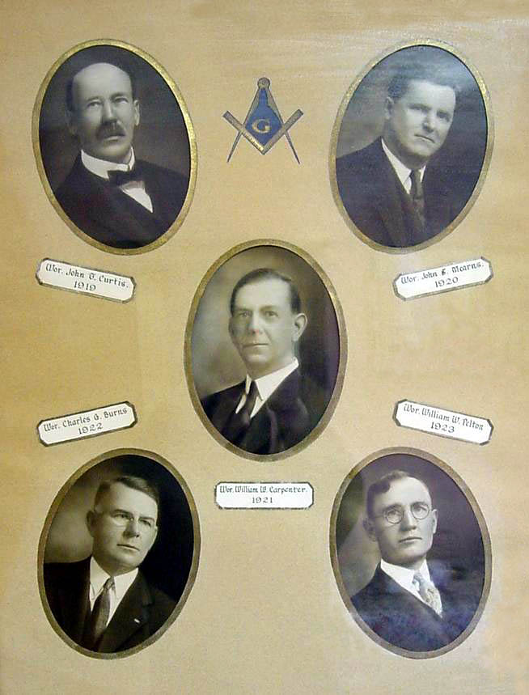
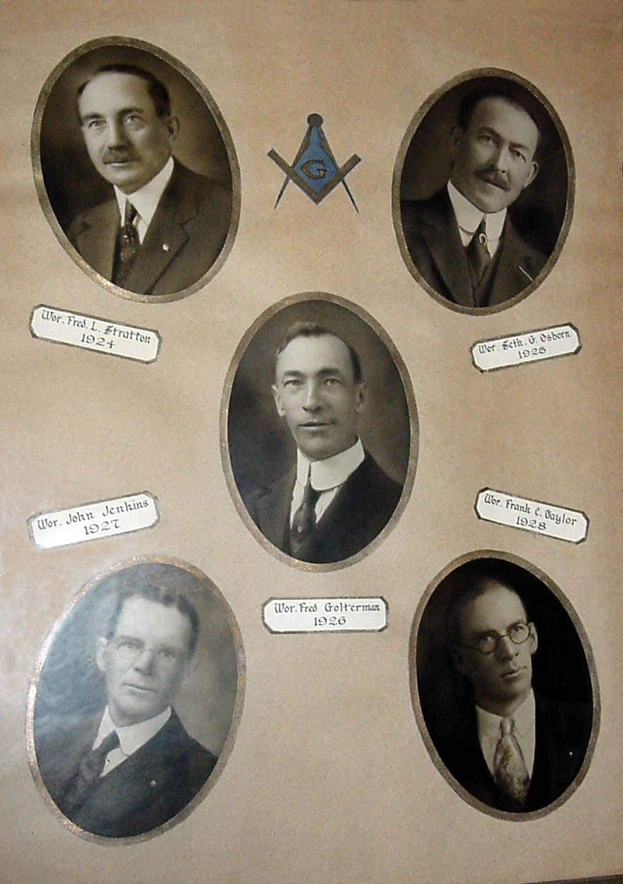
1924

In 1924 for the first and only time the lodge and the Kiamesha Chapter of Eastern Star were installed publicly.
Installed were Fred H. Stratton, Master; Seth G. Pelton, Senior Warden; Fred Golterman, Junior Warden; Henry G. Miller, Senior Deacon; John Jenkins, Junior Deacon; William B. McMillen, Treasurer; Ralph Pelton. Secretary; Clarence Maine, Chaplain; William W. Pelton, Marshal; Ralph Osborn, Senior Master of Ceremony; Frank Taylor, Junior Master of Ceremony; John V. Ennis, Senior Steward; Herman Albrecht, Junior Steward; Blake H. Bates, Organist, and Burnett H. Lefferts, Tiler.
From the beginning of the year until its end the lodge was busy conferring degrees. Prosperity seemed to be enjoyed by all and a record number of names (26) were added to the lodge rolls.
It was during this year that our degree team actually began to work. New uniforms were suggested and the work of raising money for them was begun. By the year's end it was no longer necessary to seek services of outside teams. However, this did not mean discontinuance of the practice of inviting outside teams here.
In May, 1924, the Newburgh degree team dramatized the work in an excellent manner in Monticello Lodge. They were assisted by vocal selections by their lodge quartet. About sixty from the Newburgh Lodge were present. On the same evening the altar and jewels were draped in memory of Robert McNickle, “a faithful and devoted servant of the lodge,” who had done more than any other one Master to help the lodge.
In reciprocation for the visit by the Newburgh degree team the Monticello degree team went to Newburgh on June 25th during the year Bro. Stratton served as Master.
James Mance, District Deputy Grand Master, made his official visit on November 28, 1924, when he announced that the district convention would be held at Liberty in December. The convention attended by a large delegation from Monticello Lodge including the Master.
As William B. McMillan had just completed his 29th year as Treasurer of the Monticello Lodge, a part of the year's last meeting was devoted to honoring him. He was escorted to the East and accorded Grand Honors.

1925

Elected in 1925 as Master was Seth G. Osborn, a dentist. His Senior Warden was Fred Colterman; the Junior Warden, John Jenkins; Senior Deacon, Frank C. Taylor: the Junior Deacon, Arthur W. Merritt; Treasurer, William B. McMillan; Secretary, Ralph Pelton; Senior Master of Ceremony, Leslie Hicks; Junior Master of Ceremony, Harry G. Allen; Chaplain, Luke Davies; Marshal, Fred L. Stratton; Organist, Blake H. Bates, and the Tiler, B. Lefferts.
One of the lodge's first acts was to contribute $25 for the Monticello Rotary Club's winter sports program.
With many new members who had new ideas and suggestions the lodge gradually found itself losing some of the conservatism by which it had been identified for many years.
The most urgent demand seemed to be for a greater degree of sociability than had been shown in preceding years. This, it was pointed out, could be realized with the organization of a square club.
The members of the lodge generally seemed to be in favor of the plan and Fred Stratton and John Jenkins were appointed as a committee to organize the same. They did not succeed for some reason which even they did not explain.
The year 1925 brought an addition of two future Masters to its membership, Charles Horton and Emory Stalker.
On April 10, 1925, a communication was received from Grand Master William A. Rouen, which pointed out that the Grand Lodge of the Orient of Belgium had removed the Bible from its altars, thus abandoning the requirement and belief in God. This action, the Grand Master warned, has terminated all relations existing between the Belgium Grand Lodge and the Grand Lodge of the State of New York.
The lodge had a Masonic orchestra during the year 1925 and its services were rendered so well and faithfully that the lodge voted it $25 with which to purchase new music.
A move to the more modern trend was indicated when "No Smoking" signs, for years a permanent wall decoration, were taken down.
Certificates were awarded to nine life members during the year's last meeting.

1926

One of the most energetic and enthusiastic Masons ever elected Master was Frederick Golterman, a n accountant, whose zeal for the fraternity resulted in his presence in the lodge room every Friday night.
He announced at the beginning of the year that he would open the lodge rooms every week and was willing and ready to practice or discuss any lodge problem the brethren desired to present.
His Senior Warden was John Jenkins; Frank C. Taylor was the Junior Warden; H. L. Hatch, Treasurer; Ralph Pelton, Secretary; Arthur W. Merritt, Senior Deacon; Leland Silvieus, Senior Master of Ceremony; Harry G. Allen, Junior Master of Ceremony; Clarence Maine, Chaplain; Herman Albrecht, Senior Steward; William Hoose, Junior Warden; Blake H. Bates, Organist; Fred L. Stratton, Marshal, and B. Lefferts, Tiler.
Attending the installation were 450. During the year many improvements were made. The work of procuring pictures of all the Past Masters of the lodge was started. Appointed to serve on the picture committee were Clinton N. Overton, Frank C. Taylor and James Hindley. The lodge donated $50 for the Monticello Hospital Fund.
A new lamp was presented by John H. Pabst, an oilcloth was procured and on it Bro. Ralph Masten artistically as well as instructively painted the winding stairs and other important objects alluded to in the Middle Chamber lecture.
The initiation fee was raised to $50; affiliation fee to $10; dues to $8.00 per year; the Secretary's salary was increased to $100; the Tiler's salary to $50; the Steward's to $25 each, and the Treasurer's, Organist's and Chaplain's salaries were set at $10 each.
The greatest achievement of the year was the completion of the work of redecorating the lodge room.
In appreciation for this and other outstanding work of the year the lodge had spread on the minutes a resolution of thanks which recognized the fact that funds had been raised during a Masonic day on July 20,1926, at the Amusement Park, an affair for raising funds was held at the Parish House on August 19, 1926, by the O.E.S., that the lodge room were very beautifully and artistically redecorated throughout with new draperies at the windows, new lights and fixtures added, new rugs on the ante-room floors, etc.
Those other than the Master receiving thanks in the resolution were Frank C. Taylor, Clarence Maine, John Jenkins, David Mearns, Walter R. Pelton, the Kiamesha Chapter of Eastern Star, Philip Kreuder, the interior decorator who had charge of the painting; Guilford Armstrong, Ralph Towner, Burnett Lefferts, James Hindley, Harry G. Allen, and Reuben Strong, all of whom ably assisted the Master in his work.
The expense of the undertaking was nearly $1,100 but the completed work still gives Monticello Lodge an appearance beauty which is unexcelled anywhere in this district.
Bro. Golterman was not the Master who believed in having his job half done. What he set out to do he finished and an example of his thoroughness is indicated in the lodge minutes where the Secretary noted that the Master was dissatisfied because only 44 had subscribed for the Masonic Outlook. His is a record which any Master might be proud of.

1927

John Jenkins, a life insurance agent, was elected Master for the year 1927, during which large delegations from lodges in the Delaware-Sullivan and other neighboring districts returned visits.
When the third degree was conferred upon a class of brothers on June 24 of that year there were more than 200 masons present. Fifty of this number were members of Newburgh Lodge 309.
Besides taking care of the Lodge's own sick and distressed that year the lodge gave $50 for the Grand Lodge fund for flood sufferers along the Mississippi. Also approved was a $10 donation to the Boy Scouts.
The funerals included one for Seth G. Osborn, a past Master who died in September 1927.
At the year's end nine more life members were added to the eleven which had served thirty years before 1927.
Frank C. Taylor was Senior Warden in 1927; A.W. Merritt, Junior Warden, David Mearns, Senior Deacon, Leland W. Silvieus, Junior Deacon, H.L. Hatch, Treasurer; Ralph Pelton, Secretary; Clarence Maine, Chaplain; Grant Davison, Senior Master of Ceremony; William Hoose, Junior Master of Ceremony and B.H. Lefferts, Tiler.

1928

Lodge officers for the year 1928 were Frank C. Taylor, Master; Arthur C. Merritt, Senior Warden; David Mearns, Junior Warden; H.L. Hatch, Treasurer; Ralph Pelton, Secretary; B.H. Lefferts, Tiler, and Charles G. Burns, Trustee for three years.
Considerable charity work was done during the year and included in the program was the payment of $100 toward the funeral of a brother, and the investigation of a case which resulted in the acceptance of a Mason's Widow into the Home at Utica.
Relations with those supervising the Home were close and $10 was given by Monticello Lodge for the Grand Lodge fund, for placing a bust of Commodore John Paul Jones, a group picture of M.W. William J. Wiley, his wife and daughter and a portrait of M.W. John W. Voorman, Senior Past Grand Master in the Hall of Fame at Utica.
Perhaps no Master had been more interested in his work or had a more thorough knowledge of the ritual than Bro. Taylor.
Before Grand Lodge officials frowned upon such meetings, Bro. Taylor would convene with his officers and other members of the craft in a room in the back of his store, and rehearse their work. On many occasions he would invite an automobile load of brothers to go for a ride with him and while driving to Middletown, Port Jervis and other places would go through the work of the three degrees pointing out differences that existed between the old and new rituals and improving parts of the work.
The photo committee which was headed by C. N. Overton announced on February 24, 1928 that their work was completed and much to the amazement of the brethren they reported that they had been successful in obtaining pictures of all of the past masters.
When the committee started their work in 1926, many believed that they had undertaken a hopeless task, but perseverance on the part of all, correspondence with descendents of the deceased past masters, and photographic copying eventually resulted in the finished job, which excels any photographic display of lodge Masters in this district.
Vincent Elwood, district deputy Grand Master from Hancock, made his official visit on September 28, 1928.
The initiation fee was increased from $50 to $60. The Dual Membership fee was set at $25 and an additional $10, was voted Grand Lodge for each initiate.

1929

Arthur W. Merritt, a school teacher and life insurance agent, was elected Master for the year 1929. The Senior Warden was Leland W. Silvieus. Ralph Pelton was the JunIor Warden; H. L. Hatch, Treasurer; Charles Maine, Secretary; B.H. Lefferts, Tiler, and W. W. Carpenter, Trustee for three years.
Early in the year the Fellowcraft team purchased uniforms and equipment costing about $1,000. With their needs well supplied and in possession of equipment unexcelled by any degree team in this section the members of the Fellowcraft team were both proud and anxious to participate in degree work.
They rehearsed regularly and became 80 proficient in their work that their services were sought in many other lodges.
The lodge had started to raise funds In 1924 when Harold Hifton was captain of the team. About $200 was added to the fund in 1926; another $200 was netted from a show sponsored by the team at the Rialto Theatre in 1927 and about $600 was raised during the year 1928 from Chautauqua, entertainment arranged by Bro. Frank C. Taylor.
Bro. David Mearns was captain of the team in 1929, having succeeded Bro. Hitton in 1926.
Perhaps no Master has been more attentive to the sick and distressed than Bro. Merritt. During his year and during the years that have followed, Bro. Merritt has assisted the lodge greatly in charitable work. In addition to the sums spent in 1929 for such work the lodge" voted $50 for the Boy Scouts. One of the most notable meetings of the year was on Roll Call night, when members absent for many years were present.
With the Fellowcraft Club organizer there came a desire for quarters in which to meet for recreation and club purpose. This movement resulted in the appointment of a committee to work with the trustees for the purpose of reducing the customary ten-year leases on the second floor so that the lodge would eventually be able to use this part of the building. H. Perry, of Sidney, District Deputy Grand Master, made his official visit on November 8, 1929. This was among the more important year-end meetings.

1930

The effects of the 1929 stock market crash were already being realized when Leland Ward Silvieus was elevated to the Mastership.
Despite conditions, however, the lodge enjoyed a highly successful year under his leadership.
Nine new names were added to the membership roll and five were taken away by the Grim Reaper.
Among the 1930 departed was Burnett Lefferts, the lodge's 26-year Mason, who had served faithfully, efficiently and continually over a period of eight years as the lodge's Tiler.
Another was George D. Pelton, a Past Master upon whose honored shoulders the purple of the craft had rested in 1921.
Ralph Pelton was Senior Warden during the year 1930; Grant Davison, Junior Warden; H. Lynden Hatch, Treasurer; Clarence Maine, Secretary, and William Moore was elected Trustee for three years. Burnett Lefferts was elected Tiler to serve his eighth term but died on February 1, 1930. Herman Albrecht was elected to succeed him.
A petition of the Order of Amaranth asking the lodge to reconsider a request of two years previous to rent the lodge rooms created a lively discussion and resulted in a thorough perusal of the minute books for rules and regulations regarding rental of the rooms.
Bro. Silvieus called the lodge's attention to a proposed resolution of several years previously, which would restrain the Trustees from renting the rooms to any organization other than the Blue Lodge of Masonry or the Order of Eastern Star. Because of the close relation between the Order of Eastern Star and Order of Amaranth it was cited that both organizations should be entitled to use of the lodge rooms.
Finally an amendment to the original resolution which required that the organization desiring a lease be "recognized by Grand Lodge, F. & A. M., or the Grand Chapter of Eastern Star" was submitted for approval of the lodge. Of 60 votes cast, 48 were for the amendment and 12 were against.
In addition to his regular duties as Master of the lodge, Bro. Silvieus visited the Masonic Home at Utica, attended and took part in the convention held by District Deputy Grand Master William Perry at Sidney in April and attended the Grand Lodge session.
In his report on his Grand Lodge visit Bro. Silvieus stated that eight new lodges had been organized during the year ending in June 1930, giving a total of 2,713 new members. He pointed out that there had been more unaffiliations than usual and said that Grand Lodge had expressed its disapproval of public installations.
One of the most noteworthy contributions during 1930 was made by Bro. Archibald Hargest, a Wurtsboro druggist. Bro. Hargest had watched with great interest Bro. Silvieus' progress through the chairs and shortly after he became Master Bro. Hargest wrote a third-degree drama and entrusted the new Master with the work of making it serve its purpose.
Bro. Hargest was not wrong in presenting the drama when he did. New interest grew and soon the services of the degree team were sought in New York City, Kingston, Newburgh, Port Jervis, Ellenville, Liberty and many other places.
The drama was presented for the first time on June 13, 1930, when Clyde F. Stratton, a son of Past Master Fred Stratton, Howard G. Clements and George Pick were raised.
Bro. Silvieus did not lay down his working tools and stand idly by when his year ended. His ability was recognized by the Grand Lecturer, Henry Meacham, who appointed him Assistant Grand Lecturer for the year 1931 and reappointed him until 1935. In 1938 he was appointed Grand Lodge Service Man. He served in this capacity through 1941.
Bro Silvieus believed in doing a thorough job and asked no one to do the work he thought a Master should do. He conducted funerals and mastered the ritual to a degree of perfection.
William Lieb, of Jeffersonville, was District Deputy Grand Master that year. He made his official visit on December 12 and conducted two conventions, one at Liberty on December 1, and the other at Walton on December 2. M.W. Charles Johnson, our present Grand Secretary, was then Grand Master.
As one of our lodge stewards he provides refreshments which are both satisfying and economical. In this as well as in other lodge work there are few who can equal him.
